**THE UNIVERSITY OF ZAMBIA  
SCHOOL OF NATURAL SCIENCES  
DEPARTMENT OF COMPUTER  
SCIENCE**



DEVELOPMENT OF A STUDENT RESULT PROCESSING SYSTEM

BY

MAXWELL CHEWE

CSC 4004 PROJECT

SYSTEM MANUAL

**Table of Contents**

List of Figures vi

List of Tables viii

1. **Introduction (Overview)** 1
2. **Installation** 2
   1. **Configuring the Database** 2
   2. **Configuring the Application** 2
3. **General Operations** 3
   1. **Log In** 3
   2. **Change Password** 4
   3. **Print Results** 8
   4. **Log out** 10
4. **Specific Operations** 11
   1. **HEAD TEACHER** 11
      1. **Head Teacher Dashboard** 11
      2. **Add Classes** 13
      3. **View Added Classes** 15
      4. **Edit Classes** 17
      5. **Delete Class** 18
      6. **Add Grading System** 19
      7. **View Added Grading System** 23

* + 1. **Edit Grading System** 24

* + 1. **Delete Grading System** 25
    2. **Add Subject** 26
    3. **View Added Subjects** 28
    4. **Edit Subjects……………………………………………………………………………………………………………….**30
    5. **Delete Subject…………………………………………………………………………………………………………….**31
    6. **Add Class and Subject Combination…………………………………………………………………………….**31
    7. **View Class and Subject Combination…………………………………………………………………………..**34
    8. **Delete Class and Subject Combination………………………………………………………………………..**36
    9. **Add Student……………………………………………………………………………………………………………….**36
    10. **View Added Students…………………………………………………………………………………………………**40
    11. **Edit Students………………………………………………………………………………………………………………**41
    12. **Delete Students………………………………………………………………………………………………………….**43
    13. **Add Teachers……………………………………………………………………………………………………………..**43
    14. **View Added Teachers…………………………………………………………………………………………………**45
    15. **Edit Teachers………………………………………………………………………………………………………………**47
    16. **Delete Teacher……………………………………………………………………………………………………………**48
    17. **View Results……………………………………………………………………………………………………………….**49
    18. **View Merit List for End of Term Results………………………………………………………………………**52
    19. **View Merit List for Mid Term Results………………………………………………………………………….**55
  1. **TEACHER** 58
     1. **Teacher Dashboard** 58
     2. **Add Attendance** 60
     3. **View Attendance Information** 64
     4. **Edit Attendance Information** 66
     5. **Delete Attendance Information** 68
     6. **Add End of Term Results** 68
     7. **View End of Term Results** 73
     8. **Edit End of Term Results** 76
     9. **Delete End of Term Results** 78
     10. **Add Mid Term Results** 78
     11. **View Mid Term Results** 83
     12. **Edit Mid Term Results** 86
     13. **Delete Mid Term Results** 88
     14. **View Merit List for End of Term Results** 88
     15. **View Merit List for Mid Term Results** 92
  2. **STUDENT** 95
     1. **View or Print Report Card** 95

1. **Appendix** 97

**List of Figures**

Figure 3.1: Login Page 3

Figure 3.1.1: Invalid Login 4

Figure 3.2: Head Teacher Left navigation bar 5

Figure 3.2.1: Teacher Left navigation bar 6

Figure 3.2.2: Top Bar for Students 6

Figure 3.2.3: Update Password Page 7

Figure 3.3: Student Report Card and Print Icon 8

Figure 3.3.1: Print Pop Up Window 9

Figure 3.4: Top Bar for Students 10

Figure 3.4.1: Top Bar for Head Teacher and Teachers 10

Figure 4.1.1: Head Teacher Dashboard 12

Figure 4.1.2: Left navigation bar with class names selected 13

Figure 4.1.3: Add or Edit Classes Page 14

Figure 4.1.4: Add Student Class Page 15

Figure 4.1.5: A filled Add or Edit Class Page 16

Figure 4.1.6: Edit Class Page 18

Figure 4.1.7: Left Navigation Bar with Grading System selected 19

Figure 4.1.8: Configure Grading System Page 20

Figure 4.1.9: Create Grading System Page for Selecting Class 21

Figure 4.1.10: Create Grading System Page for Setting the Grading Pattern 22

Figure 4.1.11: A filled Configure Grading System Page 23

Figure 4.1.12: Edit Grading System Page 25

Figure 4.1.13: Left Navigation Bar with Student Subjects Selected 26

Figure 4.1.14: Add or Edit Subject Page 27

Figure 4.1.15: Add Subject Page 28

Figure 4.1.16: A filled Add or Edit Subjects Page 29

Figure 4.1.17: Edit Subject Page 30

Figure 4.1.18: Left Navigation Bar with Subjects Selected 32

Figure 4.1.19: View Class and Subject Combination Page 33

Figure 4.1.20: Combine Class and Subject Page 34

Figure 4.1.21: A filled View Class and Subject Combination Page 35

Figure 4.1.22: Left Navigation Bar with Students Selected 37

Figure 4.1.23: Add or Edit Students Page 38

Figure 4.1.24: Add Student Page 39

Figure 4.1.25: A filled Add or Edit Students Page 40

Figure 4.1.26: Edit Student Page 42

Figure 4.1.27: Left Navigation Bar with Teachers Selected 43

Figure 4.1.28: Add or Edit Teachers Page 44

Figure 4.1.29: Add Teacher Page 45

Figure 4.1.30: A filled Add or Edit Teachers Page 46

Figure 4.1.31: Edit Teacher Page 48

Figure 4.1.32: Left Navigation Bar with View Results Selected 49

Figure 4.1.33: View Results Page 50

Figure 4.1.34: Student Results Page 51

Figure 4.1.35: Left Navigation Bar with Merit List Selected 52

Figure 4.1.36: Check End of Term Merit List Page 53

Figure 4.1.37: End of Term Merit List 54

Figure 4.1.38: Left Navigation Bar with Merit List Section Selected 55

Figure 4.1.39: Check Mid Term Merit List Page 56

Figure 4.1.40: Mid Term Merit List 57

Figure 4.2.1: Teacher Dashboard 59

Figure 4.2.2: Teacher Left Navigation Bar with Attendance Selected 60

Figure 4.2.3: Add or Edit Attendance Page 61

Figure 4.2.4: Add Attendance Page for Selecting Student 62

Figure 4.2.5: Add Attendance Page for Filling Attendance Information 63

Figure 4.2.6: A filled Add or Edit Attendance Page 65

Figure 4.2.7: Edit Attendance Page 67

Figure 4.2.8: Left Navigation Bar with Results Section Selected 69

Figure 4.2.9: End of Term Results Page 70

Figure 4.2.10: Publish End of Term Results Page 71

Figure 4.2.11: Publish End of Term Results Page with Input Fields For Entering Marks 72

Figure 4.2.12: A Filled End of Term Results Page 74

Figure 4.2.13: Student Report Card Showing Only End of Term Results 75

Figure 4.2.14: Edit Results Page for End of Term Results 77

Figure 4.2.15: Left Navigation Bar with Results Selected 79

Figure 4.2.16: Mid Term Results Page 80

Figure 4.2.17: Publish Mid Term Results Page 81

Figure 4.2.18: Publish Mid Term Results Page with Input Fields For Entering Marks 82

Figure 4.2.19: Mid Term Results Page Showing Results for Two Different Classes 84

Figure 4.2.20: Student Report Card Showing Both Mid Term and End of Term Results 85

Figure 4.2.21: Edit Mid Term Results Page 87

Figure 4.2.22: Teacher Left Navigation Bar with Merit List Selected 89

Figure 4.2.23: Check End of Term Merit List Page 90

Figure 4.2.24: End of Term Merit List 91

Figure 4.2.25: Teacher Left Navigation Bar with Merit List Section Selected 92

Figure 4.2.26: Check Mid Term Merit List Page 93

Figure 4.2.27: Mid Term Merit List 94

Figure 4.2.28: Report Card with both Mid and End of Term Results Published 96

**List of Tables**

Table 5: Available User Accounts…………………………………………………………………………………………………………97

1. **Introduction (Overview)**  
   The Student Result Processing System is a web based application that has three users:  
   • Head Teacher  
   • Teacher  
   • Student  
   The user manual begins with a walkthrough the installation process of the system.  
   The following user manual splits the users tasks into two general parts, which are further subdivided to provide clarity and easy navigation of particular tasks. The two parts are;  
   • General Operations  
   • Specific Operations  
   The General Operations include all the operations that are common to all the users, while the specific operations include each individual user’s specific operations, or what they can do. The user manual contains screenshots to help users easily navigate through the system.  
   Lastly the appendix contains a list of available user account details that can be used to navigate through the application.

**2 Installation**

2.0 Firstly, install XAMPP server.  
2.1 Then, Configure the Database  
The following steps will configure the application’s database.  
**STEP 1.** Navigate to phpMyAdmin  
**STEP 2.** Create a database and name it “rps”.  
**STEP 3.** Select import.  
**STEP 4.** Browse to the location where the folder rps is and open it.

**STEP 5.** Then open the database folder in rps folder and select  
‘rps.sql’.  
**STEP 6.** Select ‘Go’.

2.2 Configuring the Application  
The following steps will configure the application  
**STEP 1.** Copy the ‘rps’ folder to the htdocs folder or folder where your server hosts applications.  
**STEP 2.** Then run the web application by entering the following URL <http://localhost/rps> in the browser of your choice.

**3 General Operations**  
3.1 Log In

Once the system has been set up properly, a login page appears. Each user is expected to log into the system for them to perform most of their tasks. This function is done on the log in page. Any user that is not authenticated and logged in is automatically redirected to the login page. At this page, the user is required to provide their username and password in order to be logged in. Invalid login details are flagged by an appropriate error message. See the Passwords file for a list of usernames and passwords for users that are currently added to the System.

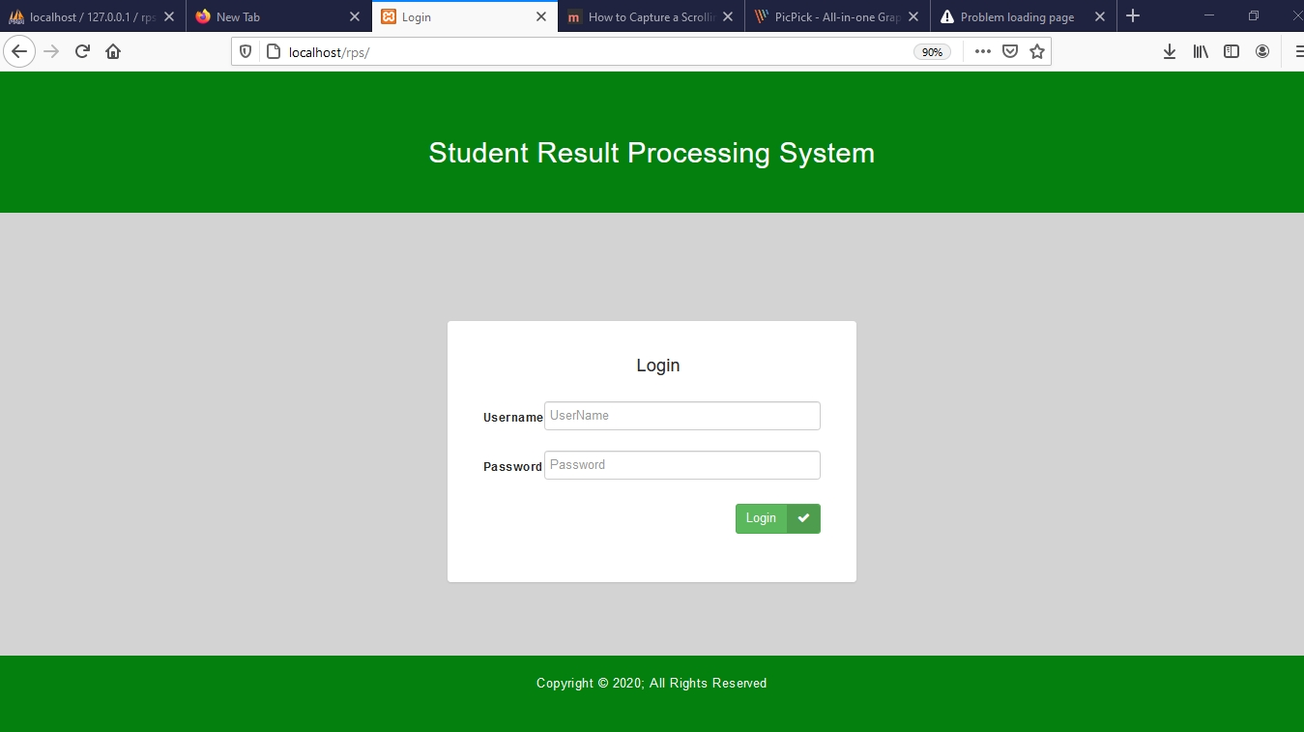

Figure 3.1 Login Page

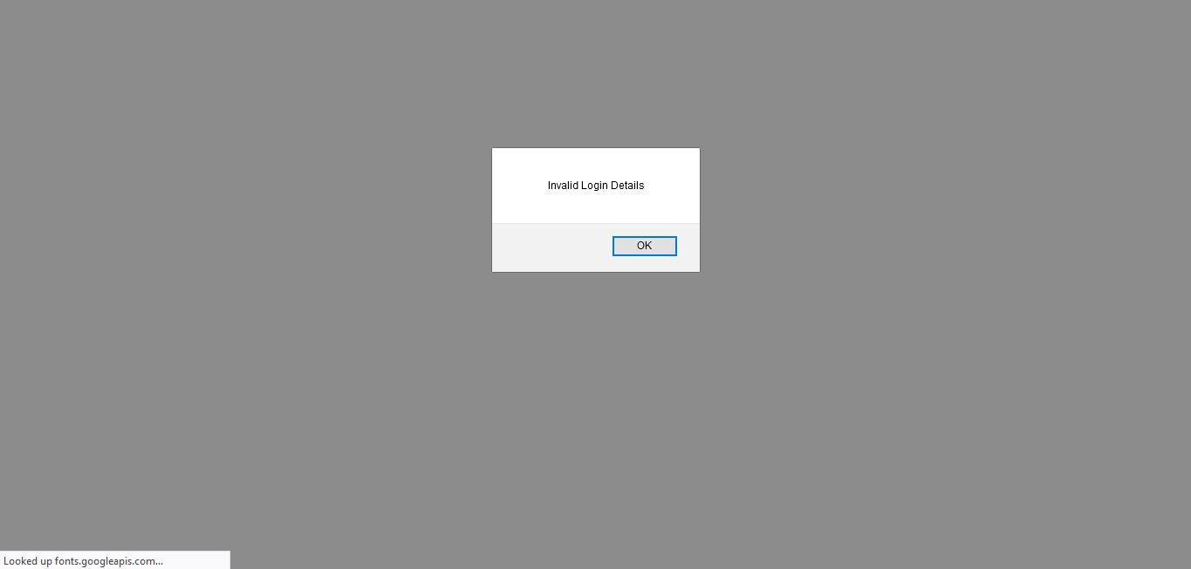

Figure 3.1.1 Invalid Login

3.2 Change Password  
This action can only be performed while a user is logged in, and is available to users. This is found at the bottom of the left navigation bar for headteacher and teachers which is labelled “Update Password” and also represented as a gear icon at the top bar for students. In the left navigation bar, the users “the head teacher and teachers”, must select update password, and at the top bar, the student must select the gear icon. This action redirects the users to the update password page.   
At this page the user is required to enter their current password, new password and a confirmation of the new password for added security. Once this is done, the user should click the ‘Submit’ button in order to save the changes. Users can also click on “Go Back” link to go back to the teacher dashboard, student main page or head teacher dashboard depending on the type of user.

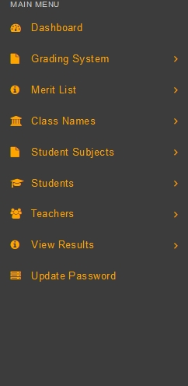

Figure 3.2 Head Teacher Left Navigation Bar

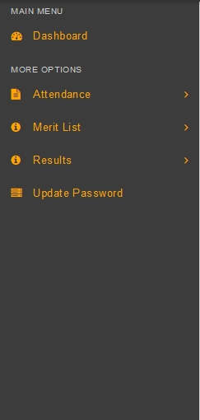

Figure 3.2.1 Teacher Left Navigation Bar

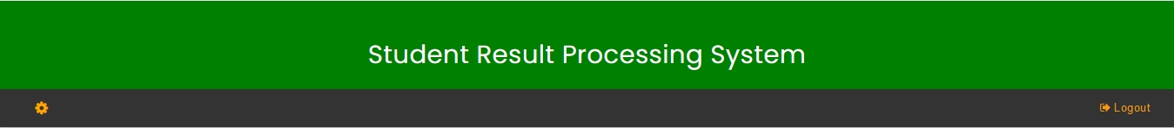

Figure 3.2.2 Top Bar For Students

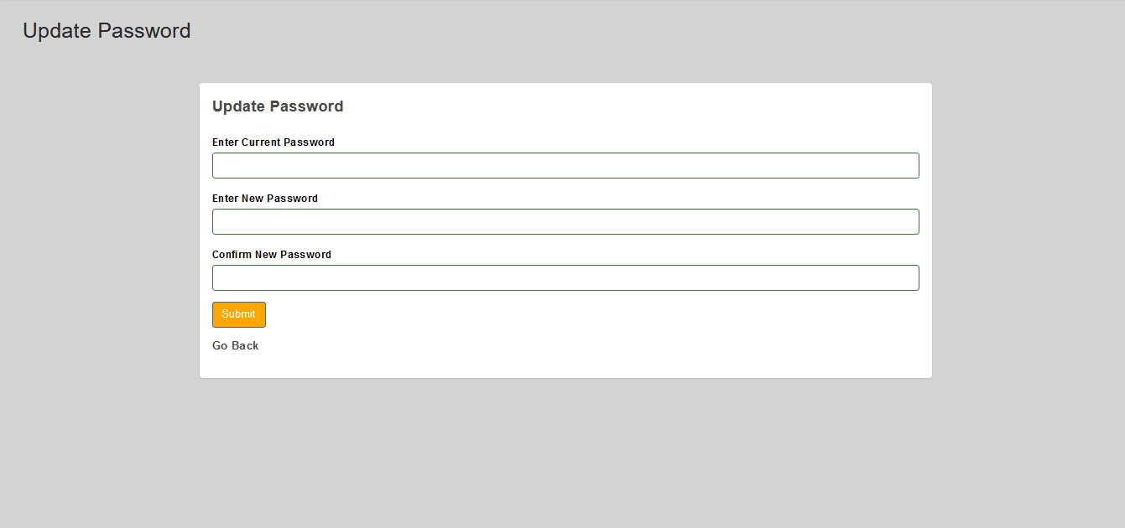

Figure 3.2.3 Update Password Page

Print Results

A user can print results by clicking on the print icon. This print icon generates a pop-up window, on this window a user can click print to print the results.

Figure 3.3 Show the student report card and the print icon.

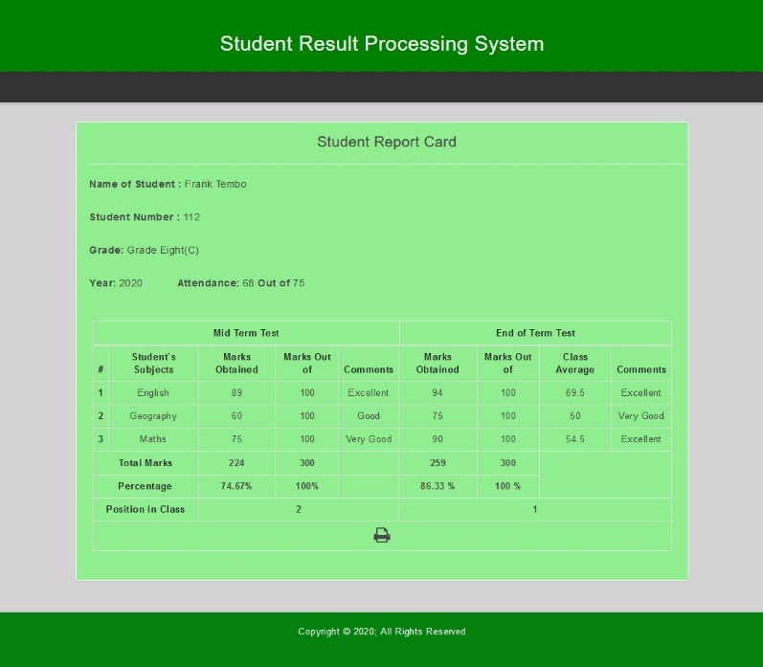

Figure 3.3 Student Report Card and Print Icon

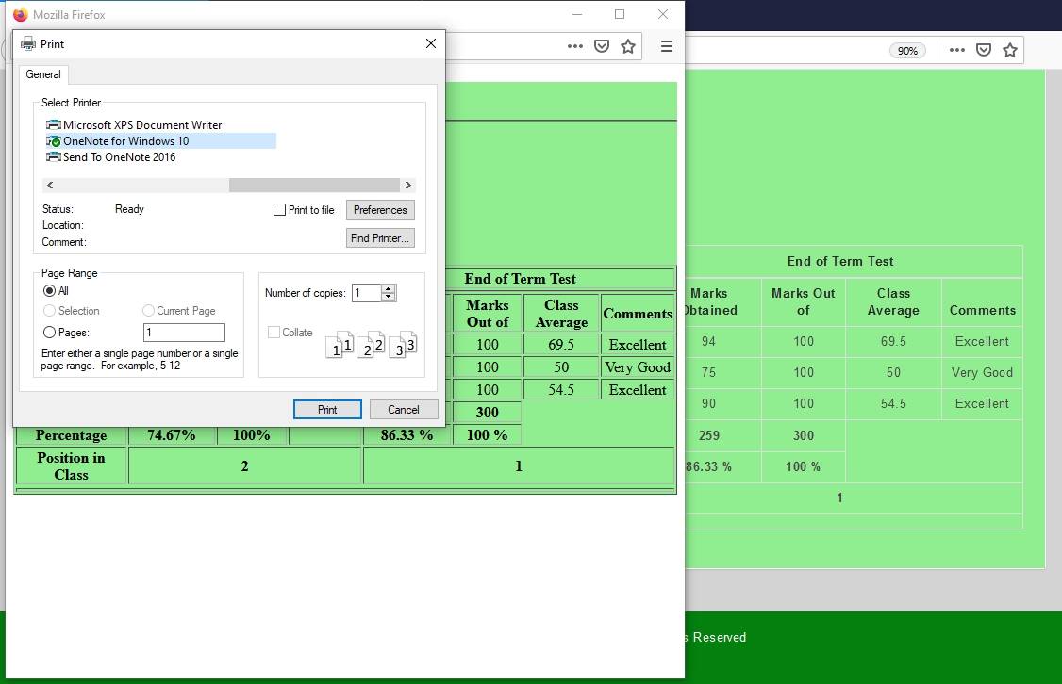

Figure 3.3.1 Print Pop Up Window

3.4 Log out

This action allows the user to log out of their account. This action can be performed by clicking on log out at the top bar. Once the user clicks on log out, they are redirected to the log in page. The logout link is found to the right of the top bar for all users.



Figure 3.4 Top bar For Students

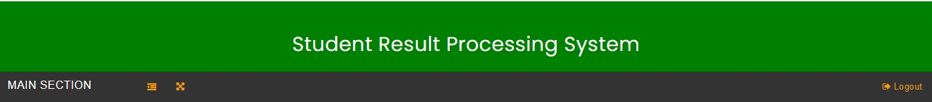

Figure 3.4.1 Top Bar For Head Teacher and Teachers

**4 Specific Operations**

These operations are categorized according to the type of user.

4.1 Head Teacher

4.1.1 Head Teacher Dashboard

Once the user “head teacher” has logged in successfully into the system, he/she should be about to see the dashboard as shown in figure 4.1.1 which has a left navigation bar, top bar, and dashboard stats. The dashboard stats display the total number of teachers, students, subjects, classes, and also the total number of published mid-term results as well as the total number of published end of term results. On these dashboard stats the user can click on view to see detailed information about the teachers, students, subjects etc. Initially the dashboard stats will display zero because no information has been added to the system yet.

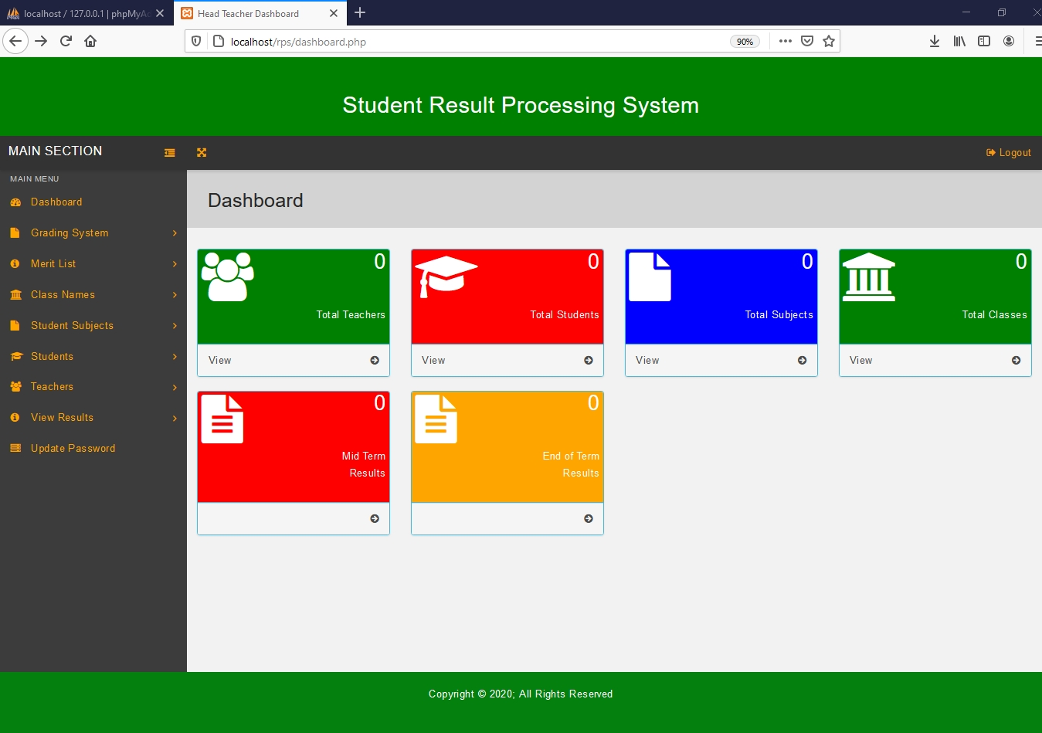

Figure 4.1.1, Head Teacher dashboard

The head teacher should be able to perform the following operations:

4.1.2 Add Classes

To add a class, click the ‘Classes’ link under class names in the left navigation bar. Then click the ‘Add Class’ button in the Add or Edit Classes page which redirects to the add student class page.

On the add student class page, fill in the input fields by providing the name of class in words, name of class in number format and the division to which the class belongs. Click the ‘submit’ button to add the class.

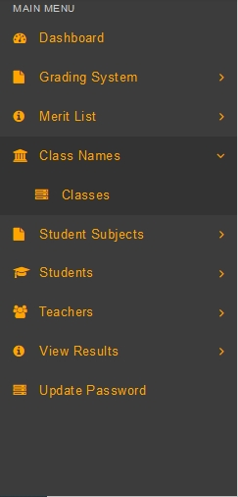

Figure 4.1.2 Left Navigation Bar With Class Names Selected

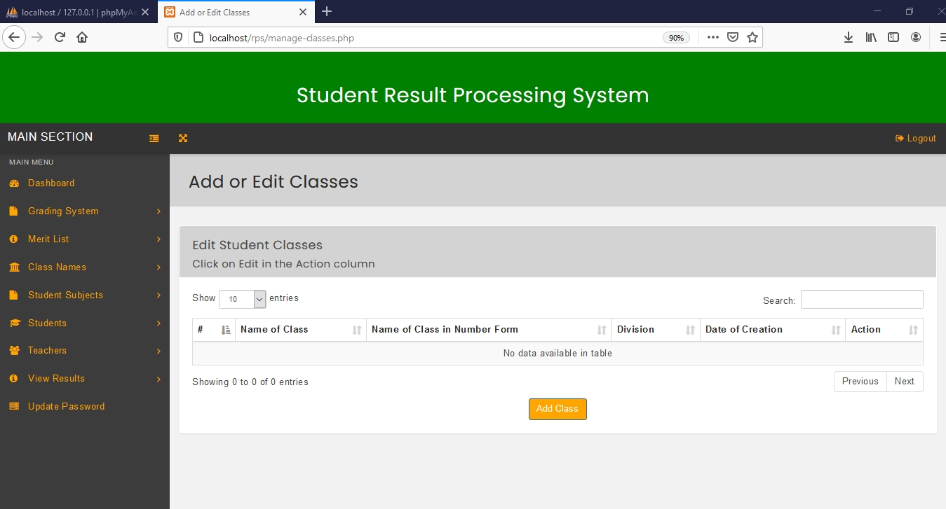

Figure 4.1.3 Add or Edit Classes Page

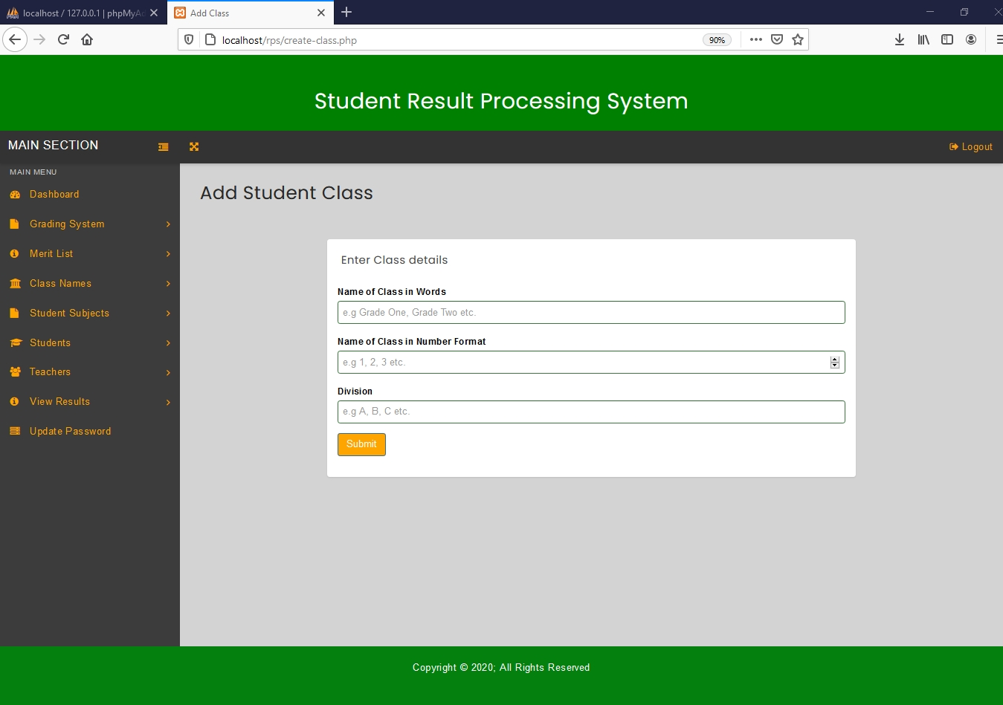

Figure 4.1.4 Add Student Class Page

4.1.3 View Added Classes

To view added classes, click on the back link at the top of the browser or click the ‘Classes’ link under class names in the left navigation bar. This action will redirect to Add or Edit Classes page which will display the added classes in a table.

The table will have the Name of Class, Name of Class in Number Format, Division and Date of Creation, as well as the available actions.

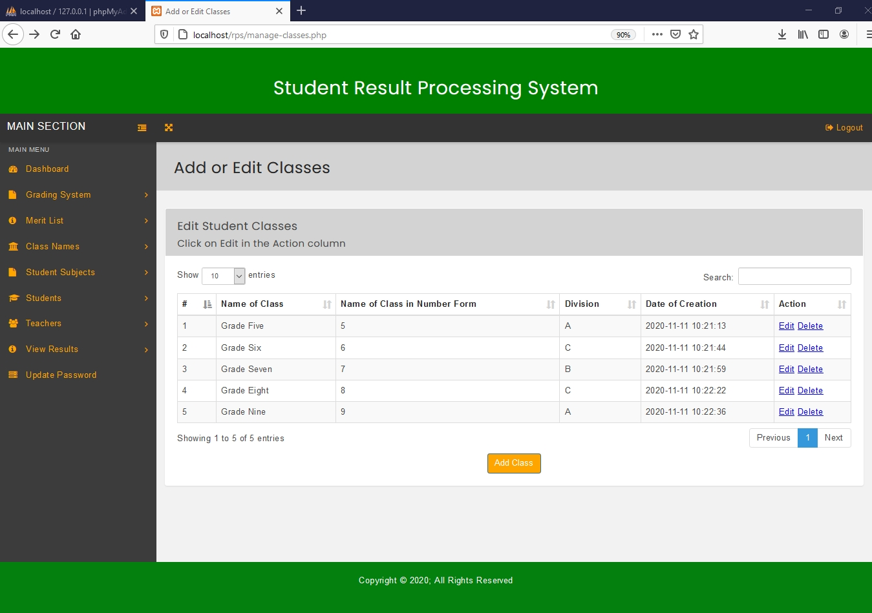

Figure 4.1.5 A filled Add or Edit Class Page

4.1.4 Edit Classes

To edit added classes, click the ‘Classes’ link under class names in the left navigation bar. This action will redirect to Add or Edit Classes page (figure 4.1.5) which will display the classes in a table.

Then click on ‘Edit’ link in Actions Column on the class you want to edit. This will lead to the edit student class page.

The edit class page, will display input fields with values already filled in, which can be changed. A user “head teacher” can edit the name of class, name of class in number format, as well as the Division. To save the changes made click the ‘submit’ button. To go back click the ‘Back’ link for the browser.

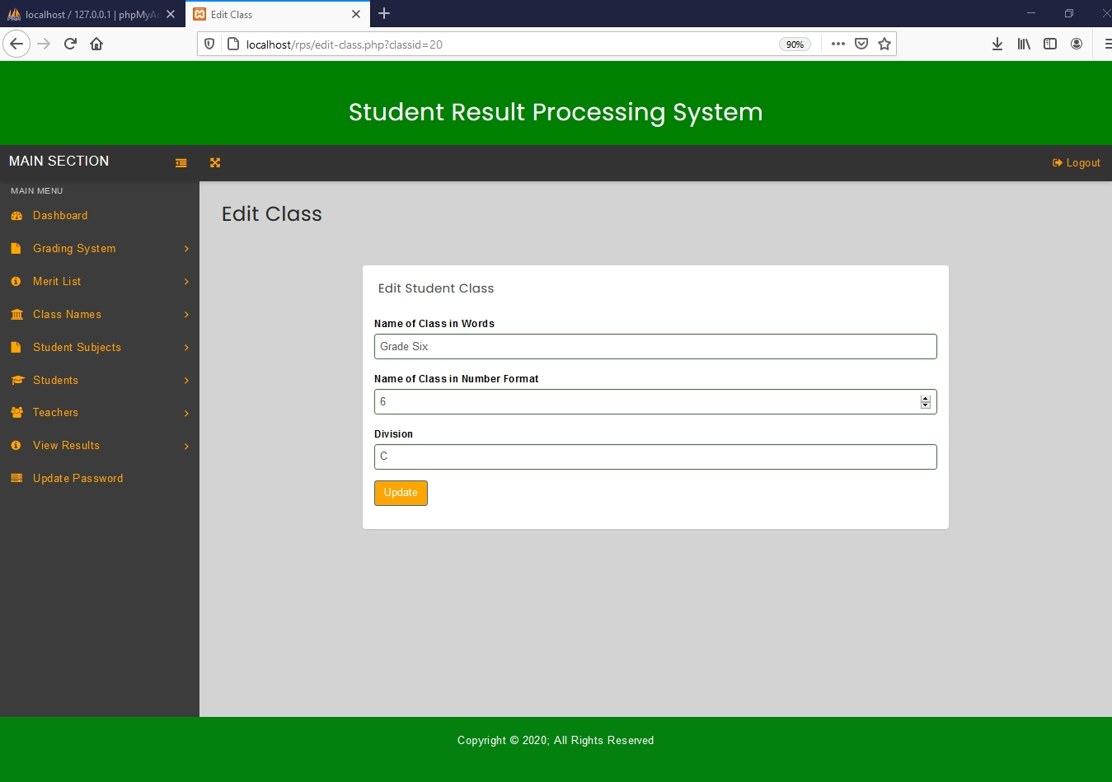

Figure 4.1.6 Edit Class Page

4.1.5 Delete Class

To delete a class, click the ‘Classes’ link under class names in the left navigation bar. This action will redirect to Add or Edit Classes page (figure 4.1.5) which will display the classes in a table.

Then click on ‘Delete’ link in Actions Column on the class you want to delete. Then the class will be deleted from the system.

4.1.6 Add Grading System

To add a grading pattern, click the ‘Grading System’ link under Grading System in the left navigation bar. This will lead to configure grading system page. Then click the ‘Add’ button on the Configure Grading System page which leads to another page called create grading system where you can select the class for which you want to create a grading system. Then a page with input fields appears where can set the grading pattern. Then after all fields have been filled correctly, Click the ‘submit’ button to add the grading pattern.

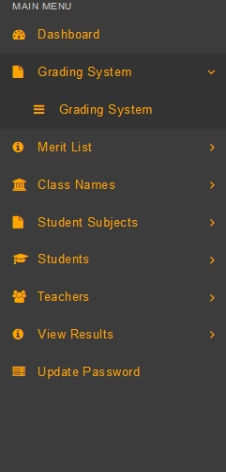

Figure 4.1.7, Left Navigation Bar with Grading System Selected

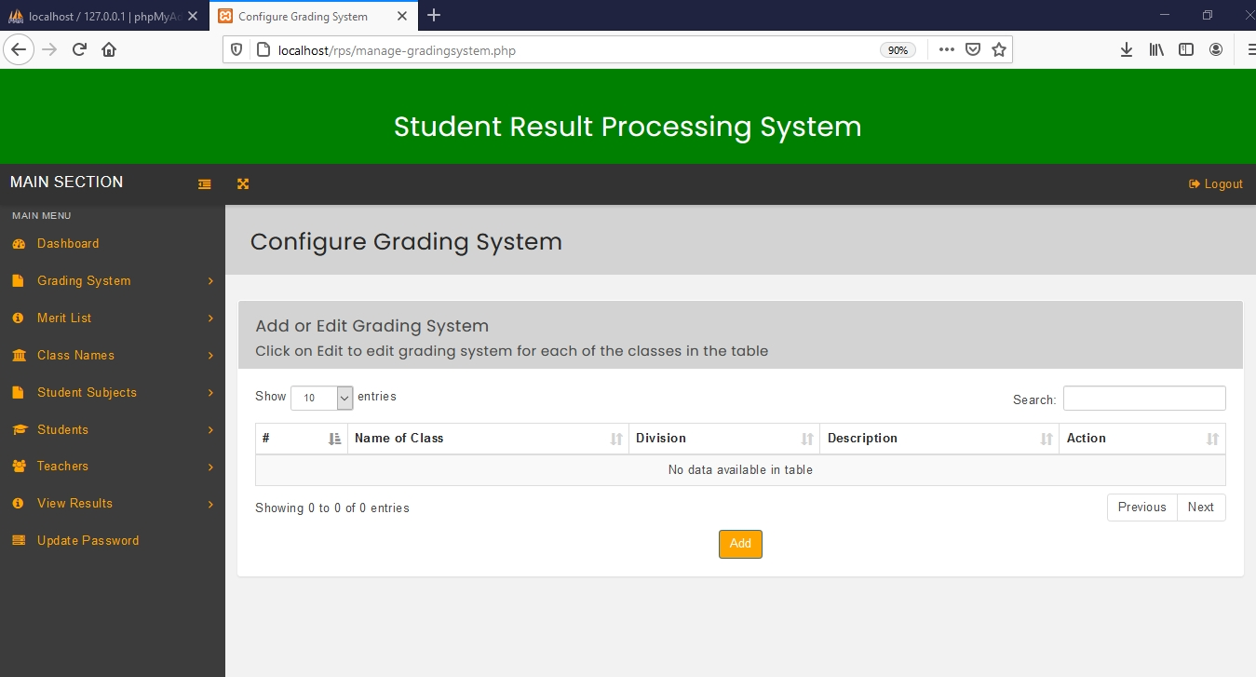

Figure 4.1.8, Configure Grading System page

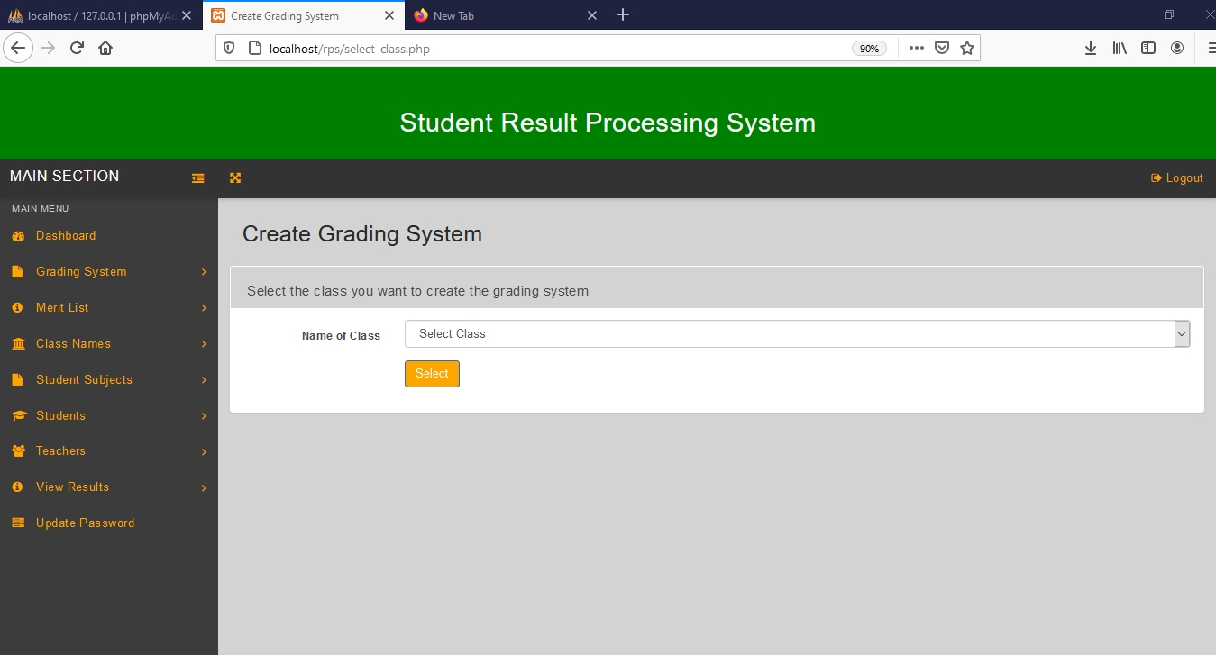

Figure 4.1.9, Create Grading System page for selecting student class

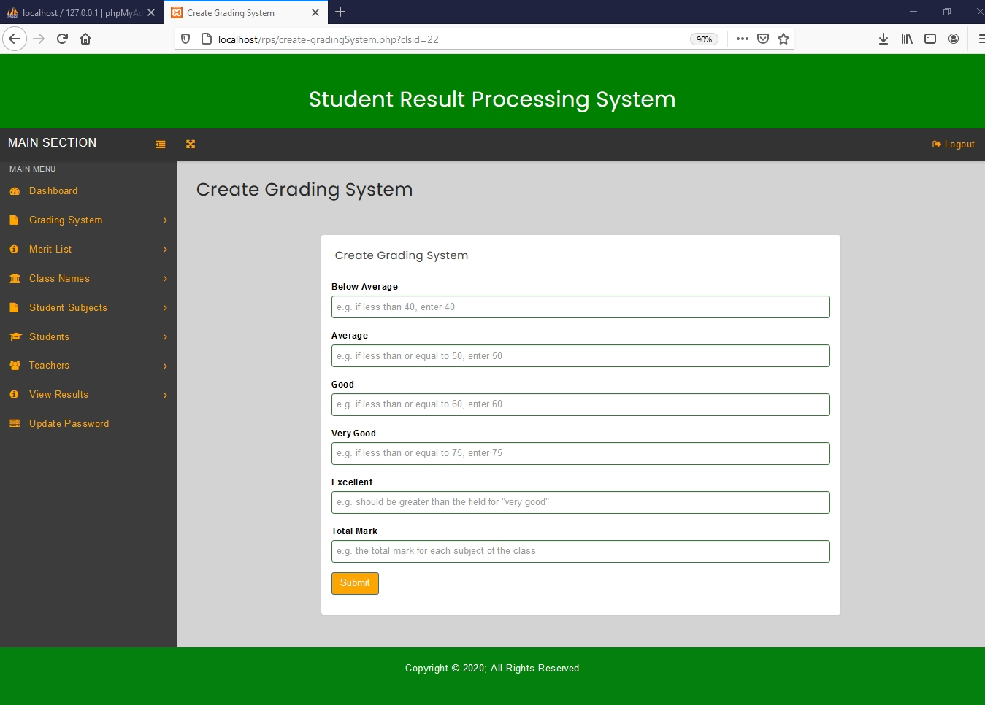

Figure 4.1.10, Create Grading System Page for Setting the Grading Pattern

4.1.7 View Added Grading System

To view added grading system, click on the back link at the top of the browser or click the ‘Grading System’ link under Grading system in the left navigation bar. This action will redirect to Configure Grading System page which will display the name of class and division to which the grading system belongs as well as a brief description of grading system and available actions.

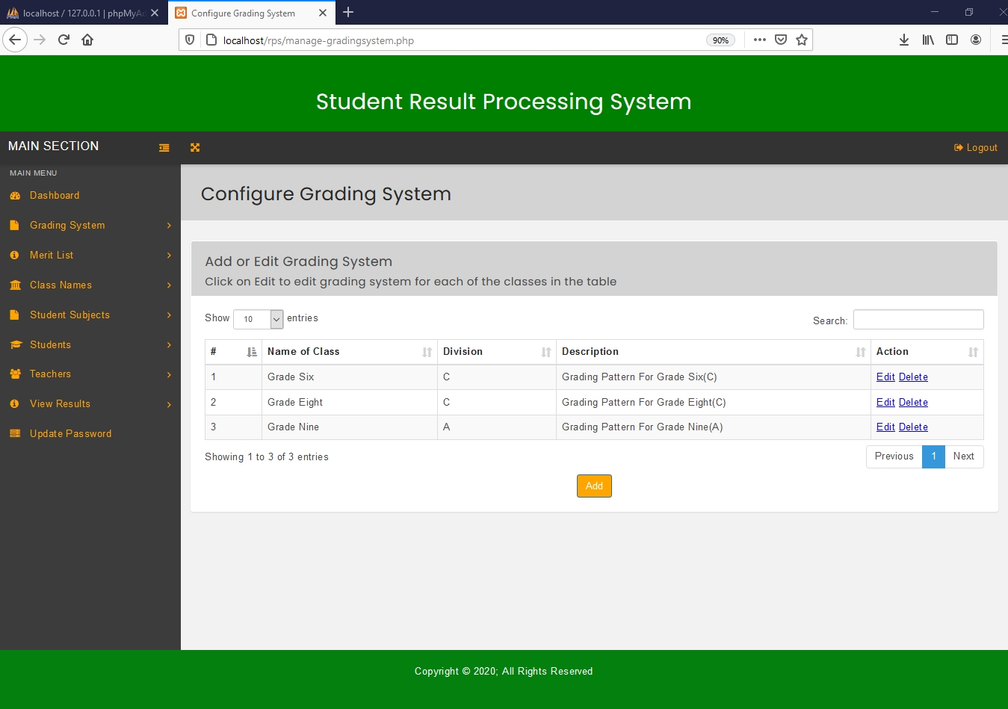

Figure 4.1.11, A Filled Configure Grading System Page

4.1.8 Edit Grading System

To edit added Grading System, click the ‘Grading System’ link under Grading System in the left navigation bar. This action will redirect to Configure Grading System page (Figure 4.1.11) which contains a table which displays the names of classes to which a grading system belongs.

Then click on ‘Edit’ link in Actions Column on the name of Grading Pattern you want to edit. This will lead to the edit Grading System page.

The grading system page, will display input fields with values already filled in, which can be changed. All fields can be edited or replaced with new values. To save the changes made click the ‘Update’ button. To go back click the ‘Back’ link for the browser.

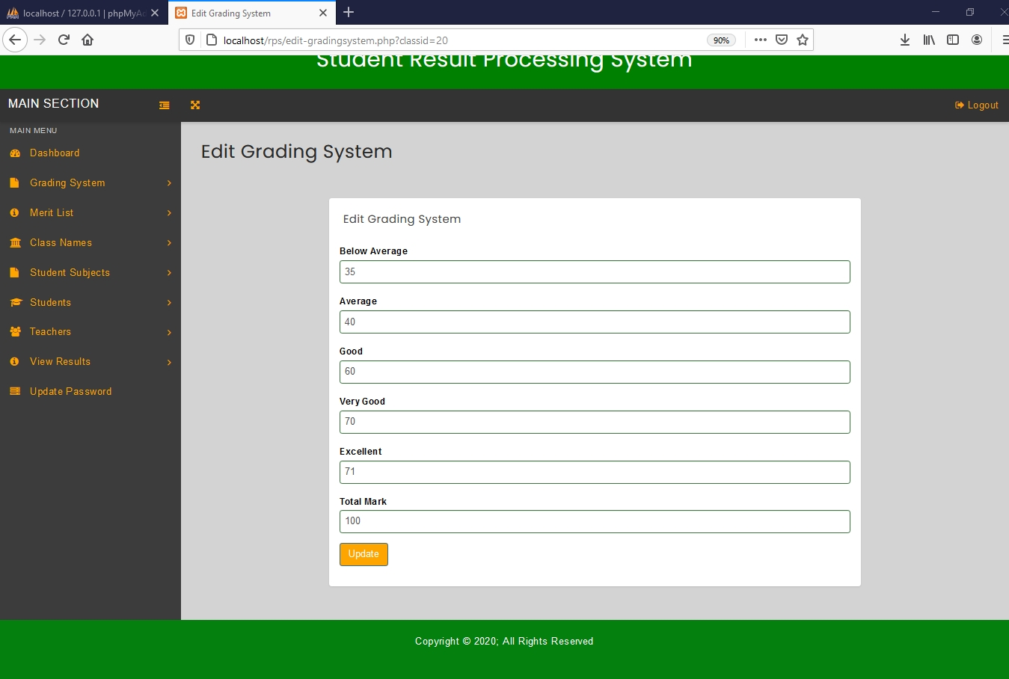

Figure 4.1.12, Edit Grading System page

4.1.9 Delete Grading System

To delete a Grading pattern, click the ‘Grading System’ link under Grading in the left navigation bar. This action will redirect to Configure Grading System page (Figure 4.1.11) which will display the names of classes to which the grading system belongs in a table.

Then click on ‘Delete’ link in Actions Column on the row containing the description of grading system you want to delete. Then the Grading System will be deleted from the system.

4.1.10 Add Subject

To add a subject, click the ‘Subjects’ link under Student Subjects on the left navigation bar. Then click the ‘Add Subject’ button on the Add or Edit Subjects page which redirects to the add subject page.

On the add subject page, fill in the input fields by providing the name of subject and the subject code. Click the ‘submit’ button to add the subject.

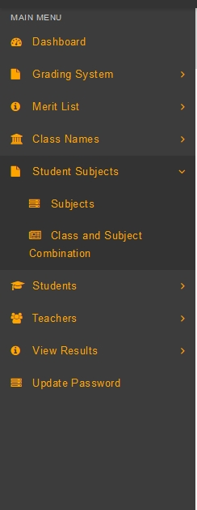

Figure 4.1.13, Left navigation bar with student subjects selected

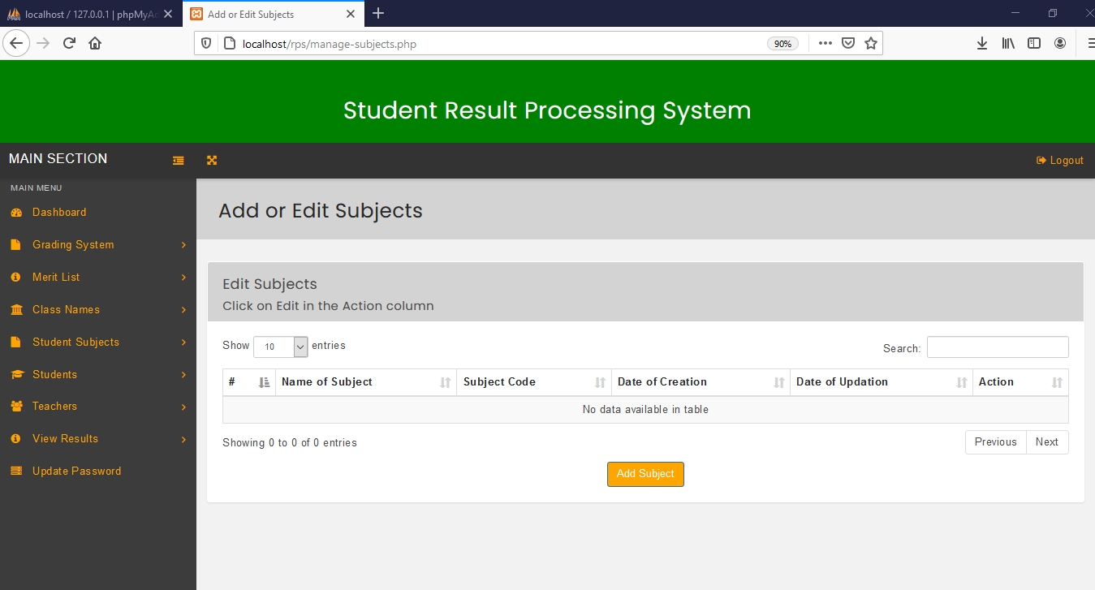

Figure 4.1.14, Add or Edit Subject page.

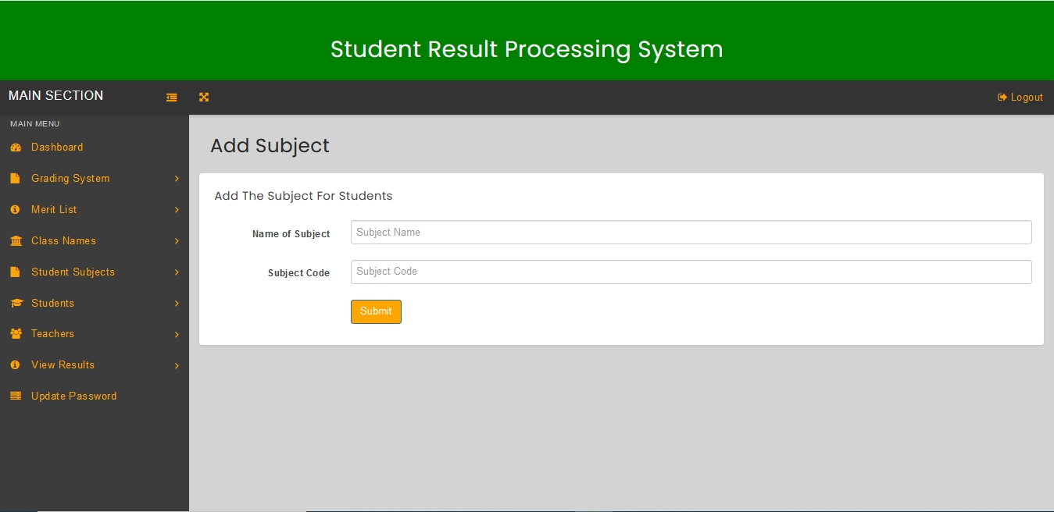

Figure 4.1.15, Add Subject page

4.1.11 View Added Subjects

To view added subjects, click on the back link for the browser or click the ‘Subjects’ link under Student Subjects in the left navigation bar. This action will redirect to Add or Edit Subjects page which will display the added subjects in a table.

The table will have the Name of Subject, Subject Code, Date of Creation, Date of Updation, as well as an action column.

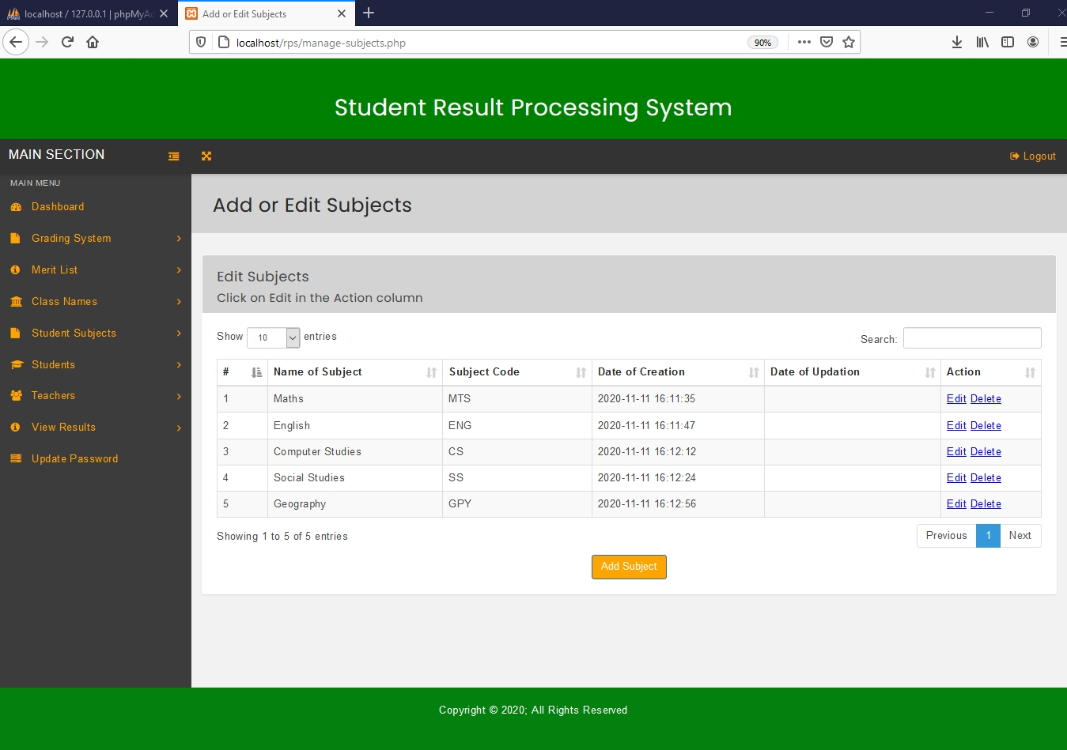

Figure 4.1.16, A filled Add or Edit Subjects page

4.1.12 Edit Subjects

To edit added subjects, click the ‘Subject’ link under Student Subjects in the left navigation bar. This action will redirect to Add or Edit Subject page (Figure 4.1.16) which will display the subjects in a table.

Then click on ‘Edit’ link in Actions Column on the subject you want to edit. This will lead to the edit subject page.

The edit subject page, will display input fields with values already filled in, which can be changed. The name of subject and subject code can be edited or changed. To save the changes made click the ‘submit’ button. To go back click the ‘Back’ link.

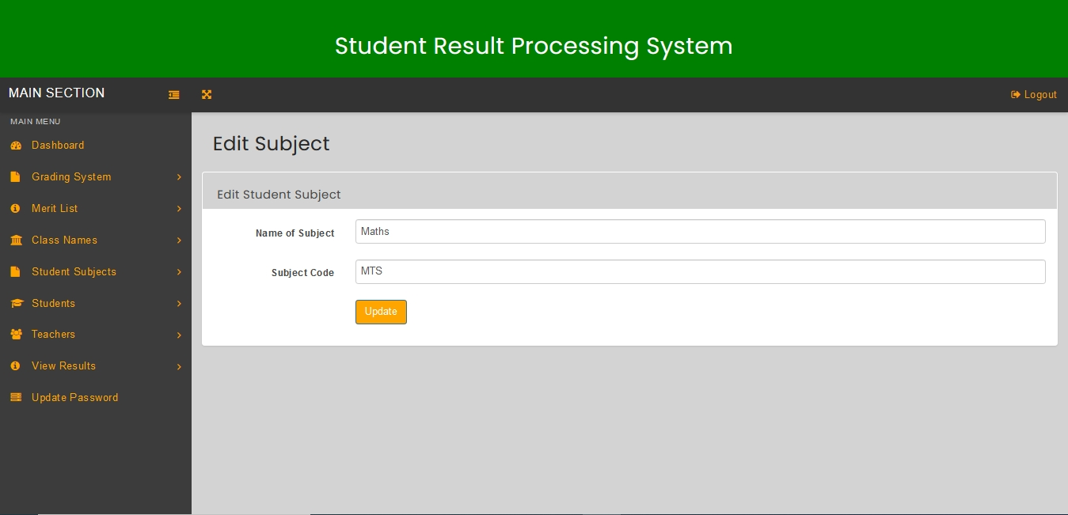

Figure 4.1.17, Edit Subject page.

4.1.13 Delete Subject

To delete a subject, click the ‘subjects’ link under student subjects on the left navigation bar. This action will redirect to Add or Edit Subjects page (Figure 4.1.16) which will display the subjects in a table.

Then click on ‘Delete’ link in Actions Column on the subject you want to delete. Then the subject will be deleted from the system.

4.1.14 Add Class and Subject Combination

To add class and subject combination, click the ‘Class and Subject Combination’ link under Student Subjects on the left navigation bar. This leads to the view class and subject combination page. On this page, click the ‘Add Combination’ button which redirects to the combine class and subject page.

On the combine class and subject page, fill in the input fields by providing the name of class and name of subject. Click the ‘combine’ button to combine the class and subject.

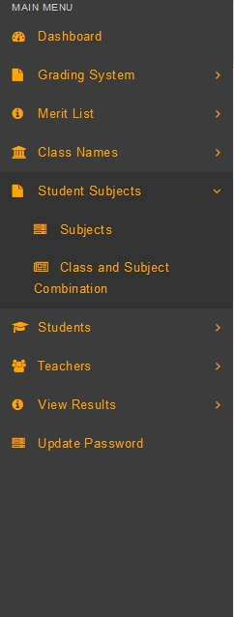

Figure 4.1.18, Left navigation bar with student subjects selected

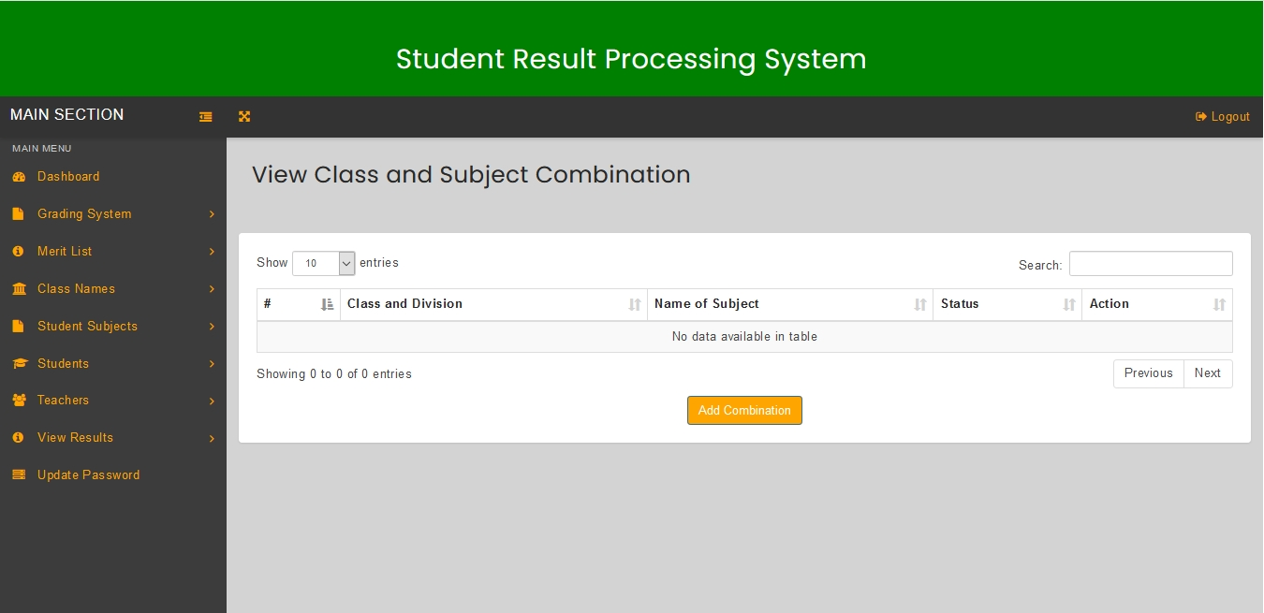

Figure 4.1.19, View Class and Subject Combination page

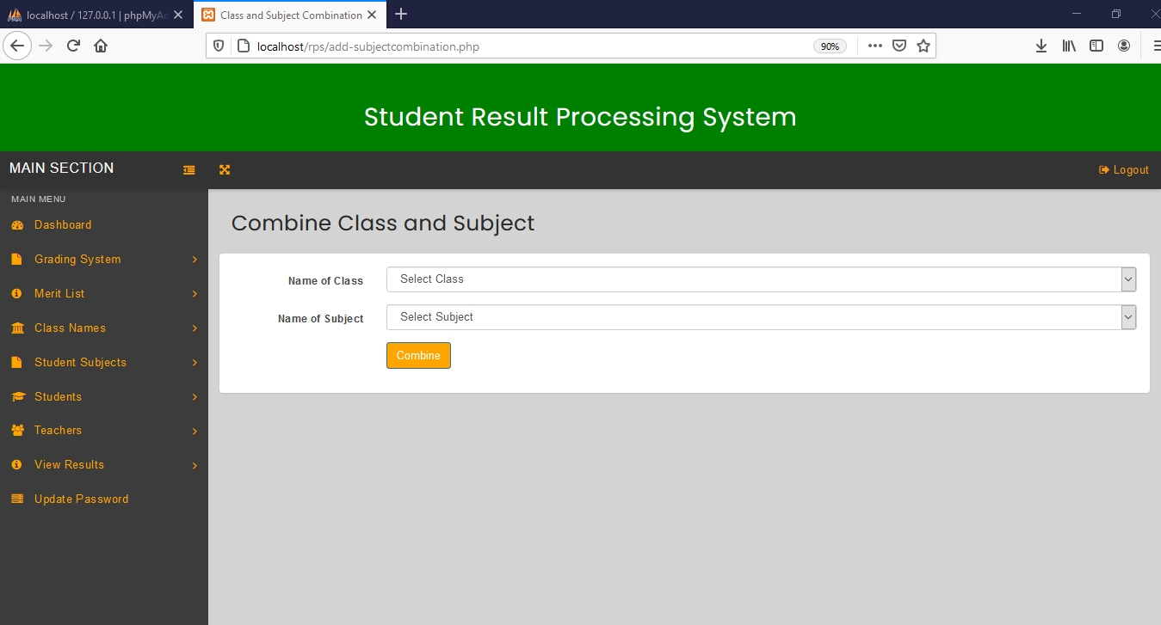

Figure 4.1.20, Combine Class and Subject page

4.1.15 View Class and Subject Combination

To view added class and subject combination, click on the back link for the browser or click the ‘Class and Subject combination’ link under Student Subjects on the left navigation bar. This action will redirect to view class and subject combination page which will display the added class and subject combinations in a table.

The table will have the Class and Division, Name of Subject, Status as well as available actions.

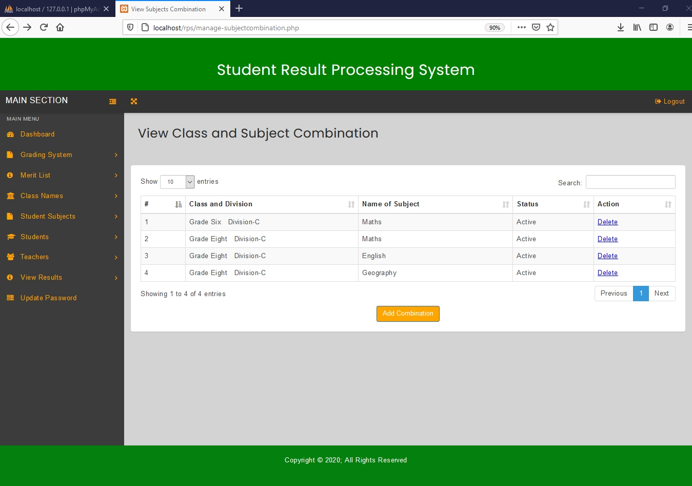

Figure 4.1.21, A filled View Class and Subject Combination page

4.1.16 Delete Class and Subject Combination

To delete class and subject combination, click the ‘class and subject combination’ link under student subjects on the left navigation bar. This action will redirect to View Class and Subject Combination page (Figure 4.1.21) which will display the class and subject combinations in a table.

Then click on ‘Delete’ link in Actions Column on the class and subject combination you want to delete. Then the class and subject combination will be deleted from the system.

4.1.17 Add Student

To add a student, click the ‘students’ link under Students on the left navigation bar. Then click the ‘Add Student’ button on the Add or Edit Students page which redirects to the add student page.

On the add student page, fill in the all the input fields. Then Click the ‘submit’ button after you are done, to add the student.

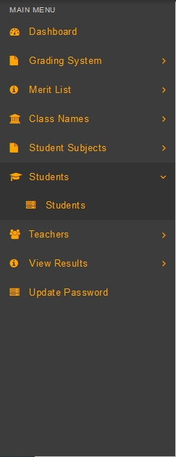

Figure 4.1.22, Left navigation bar with students selected

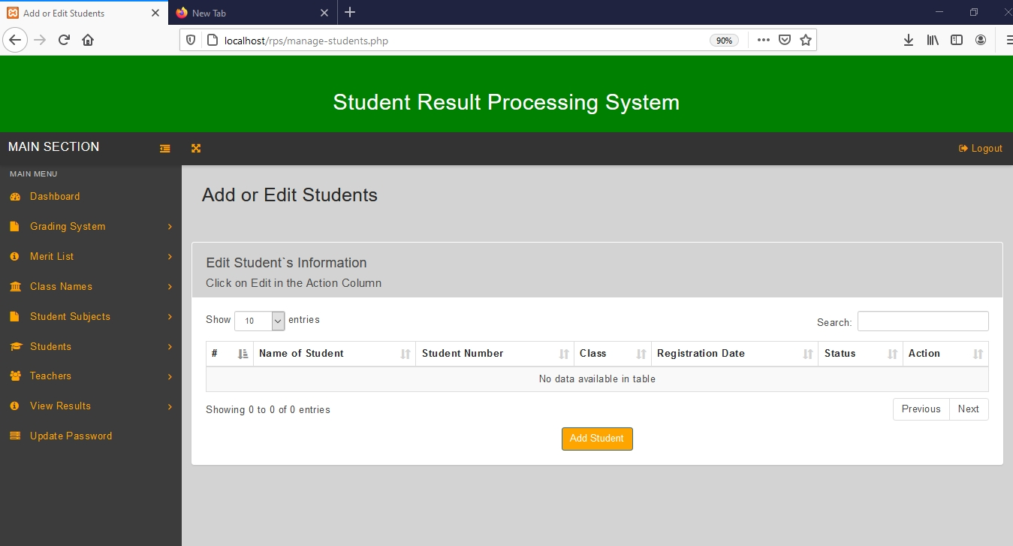

Figure 4.1.23, Add or Edit Students page.

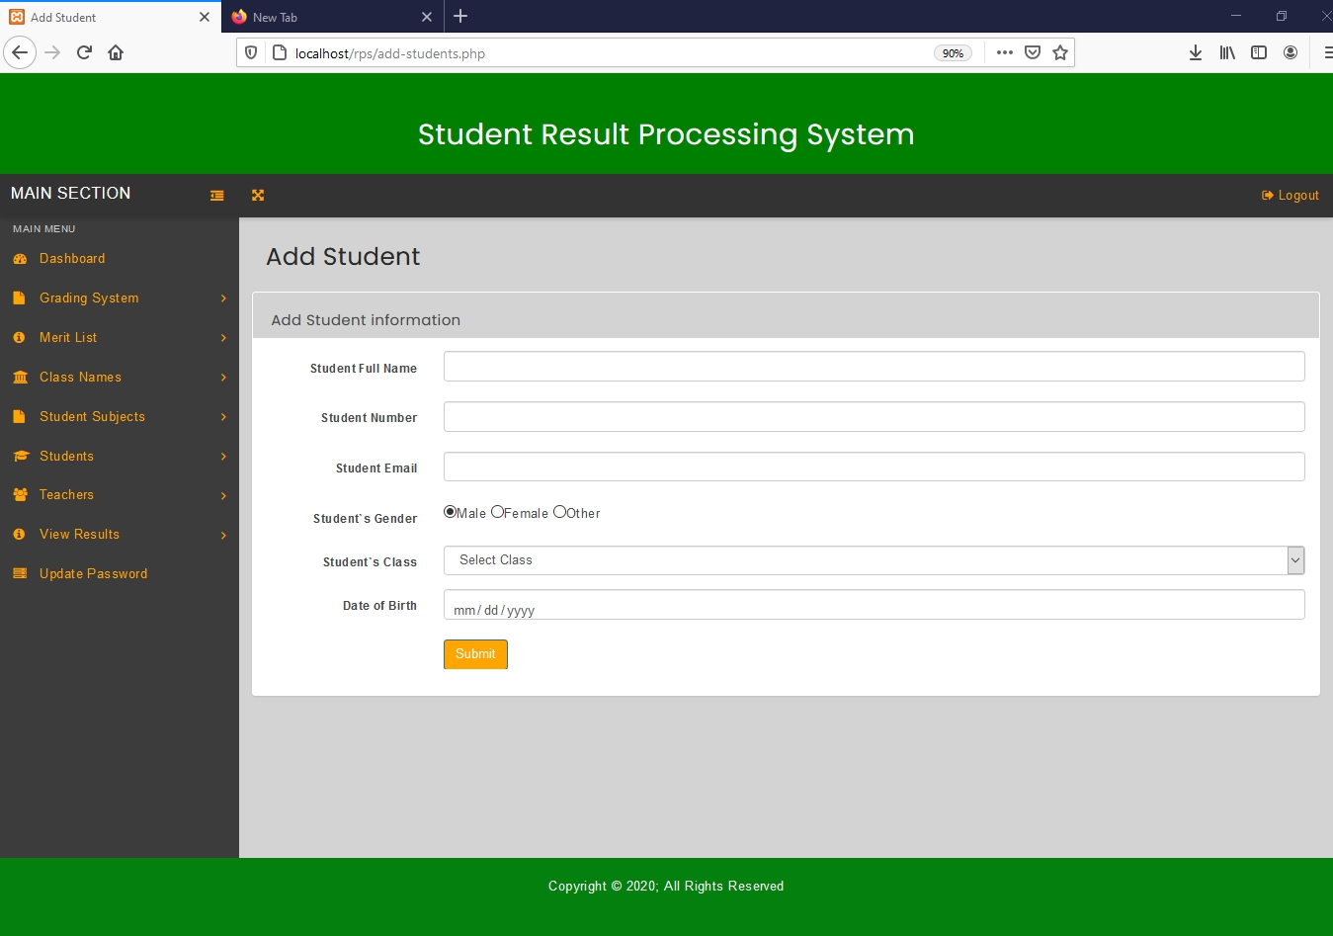

Figure 4.1.24, Add Student page

4.1.18 View Added Students

To view added students, click on the back link for the browser or click the ‘Students’ link under Students in the left navigation bar. This action will redirect to Add or Edit Students page which will display the added students in a table.

The table will have the Name of Student, Student Number, Class, Registration Date, status, as well as an action column.

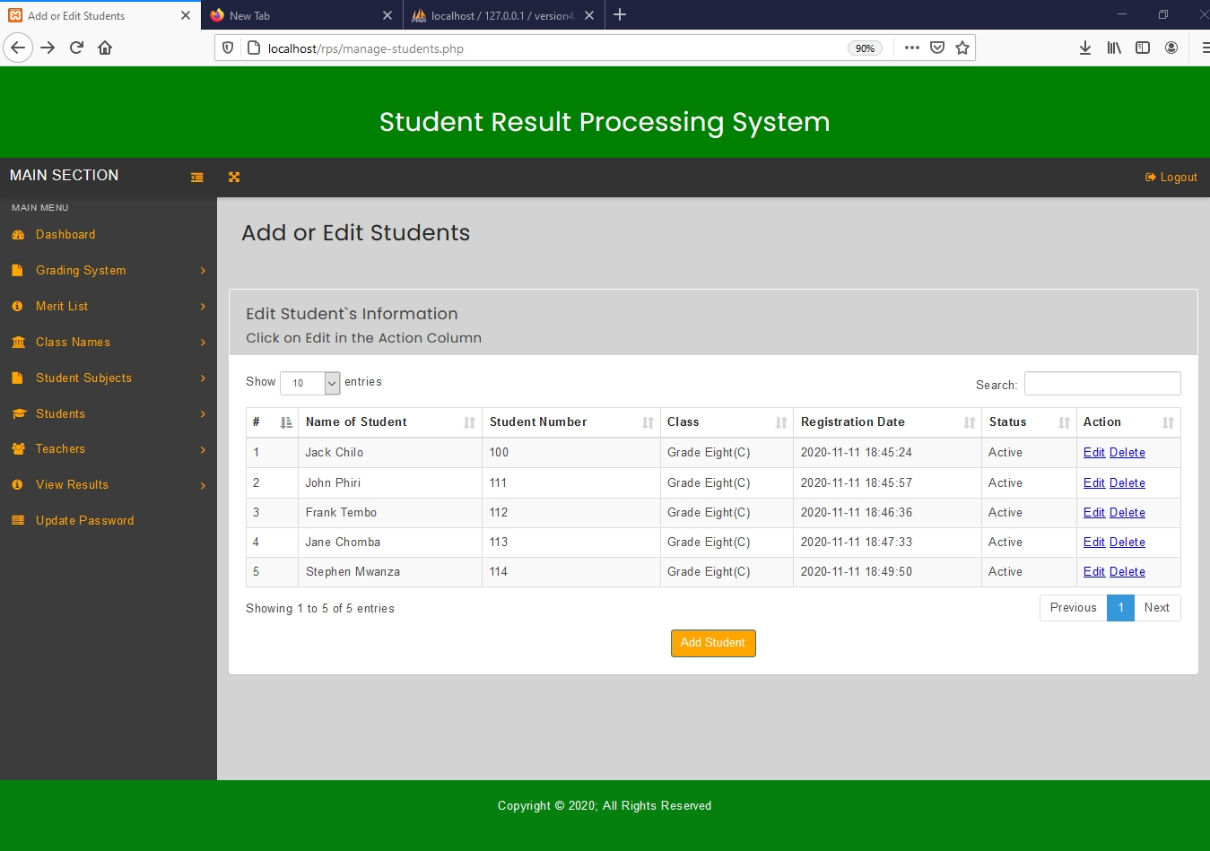

Figure 4.1.25, A filled Add or Edit Students page

4.1.19 Edit Students

To edit added subjects, click the ‘Student’ link under Students in the left navigation bar. This action will redirect to Add or Edit Student page (Figure 4.1.25) which will display the students in a table.

Then click on ‘Edit’ link in Actions Column on the student you want to edit. This will lead to the edit student page.

The edit student page, will display input fields with values already filled in, which can be changed. All the fields can be edited and their values replaced except for the student`s class field. To save the changes made click the ‘update’ button. To go back click the ‘Back’ link.

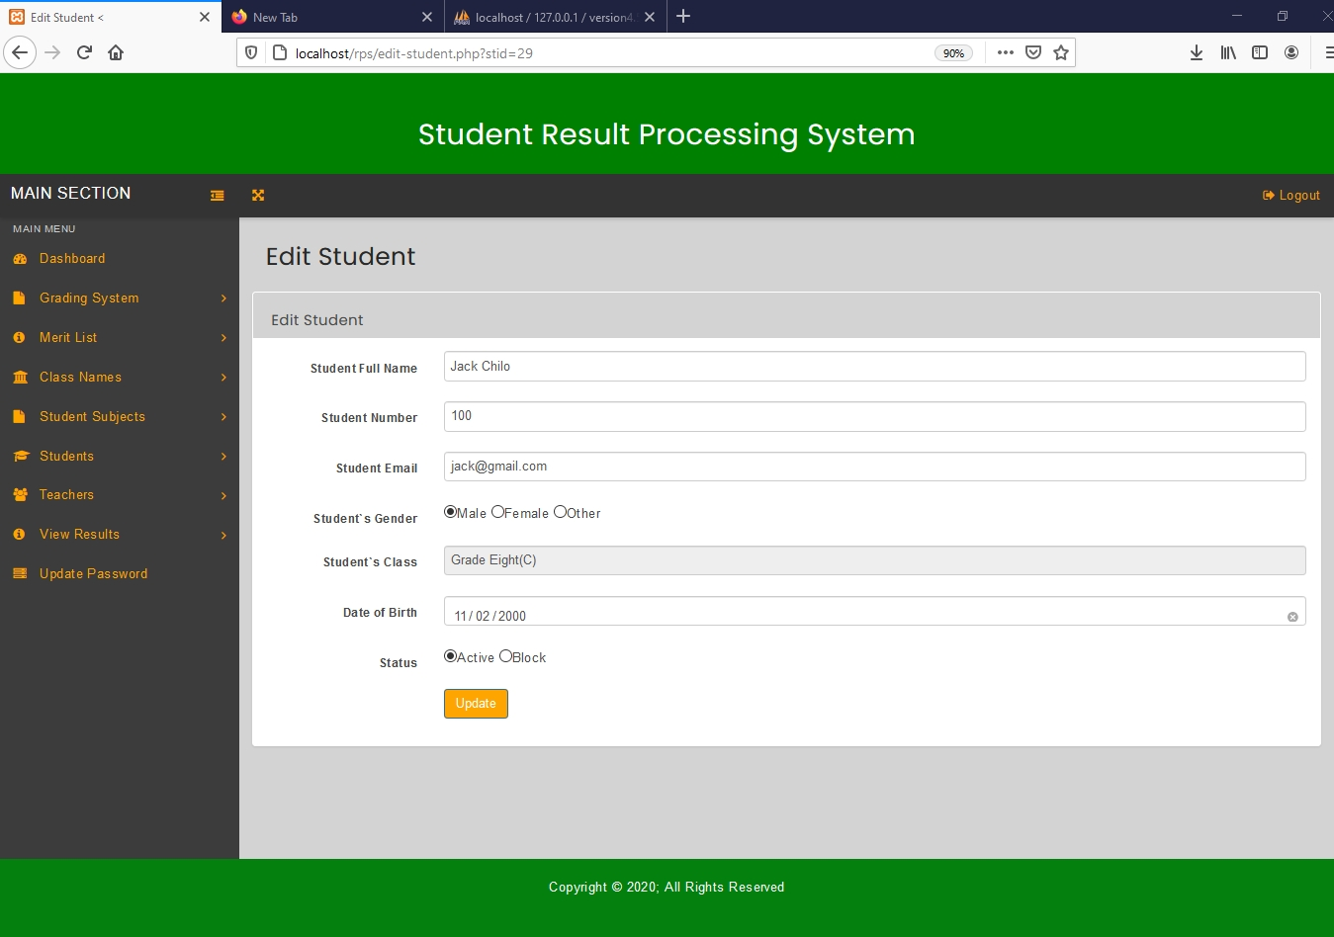

Figure 4.1.26, Edit Student page

4.1.20 Delete Students

To delete a student, click the ‘students’ link under students on the left navigation bar. This action will redirect to Add or Edit Students page (Figure 4.1.25) which will display the students in a table.

Then click on ‘Delete’ link in Actions Column for the student you want to delete. Then the student will be deleted from the system.

4.1.21 Add Teachers

To add a teacher, click the ‘teachers’ link under teachers on the left navigation bar. Then click the ‘Add Teacher’ button on the Add or Edit Teachers page which redirects to the add teacher page.

On the add teacher page, fill in the all the input fields. Then Click the ‘submit’ button after you are done, to add the teacher.

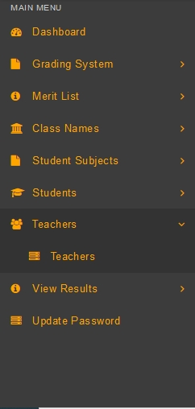

Figure 4.1.27, Left navigation bar with teachers selected.

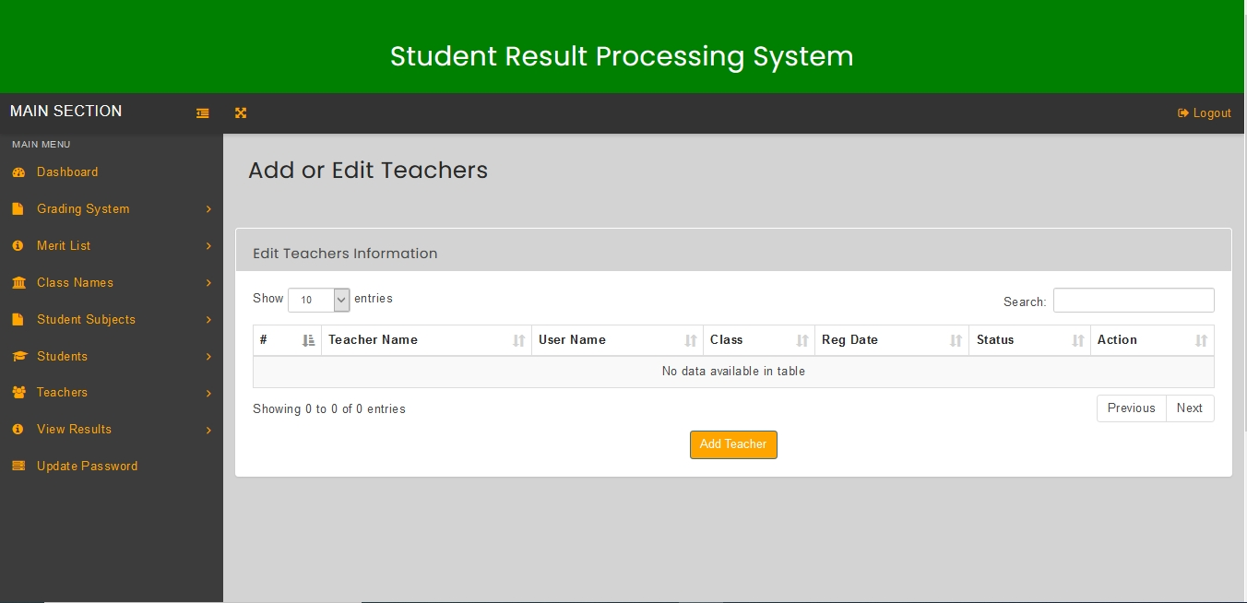

Figure 4.1.28, Add or Edit Teachers Page

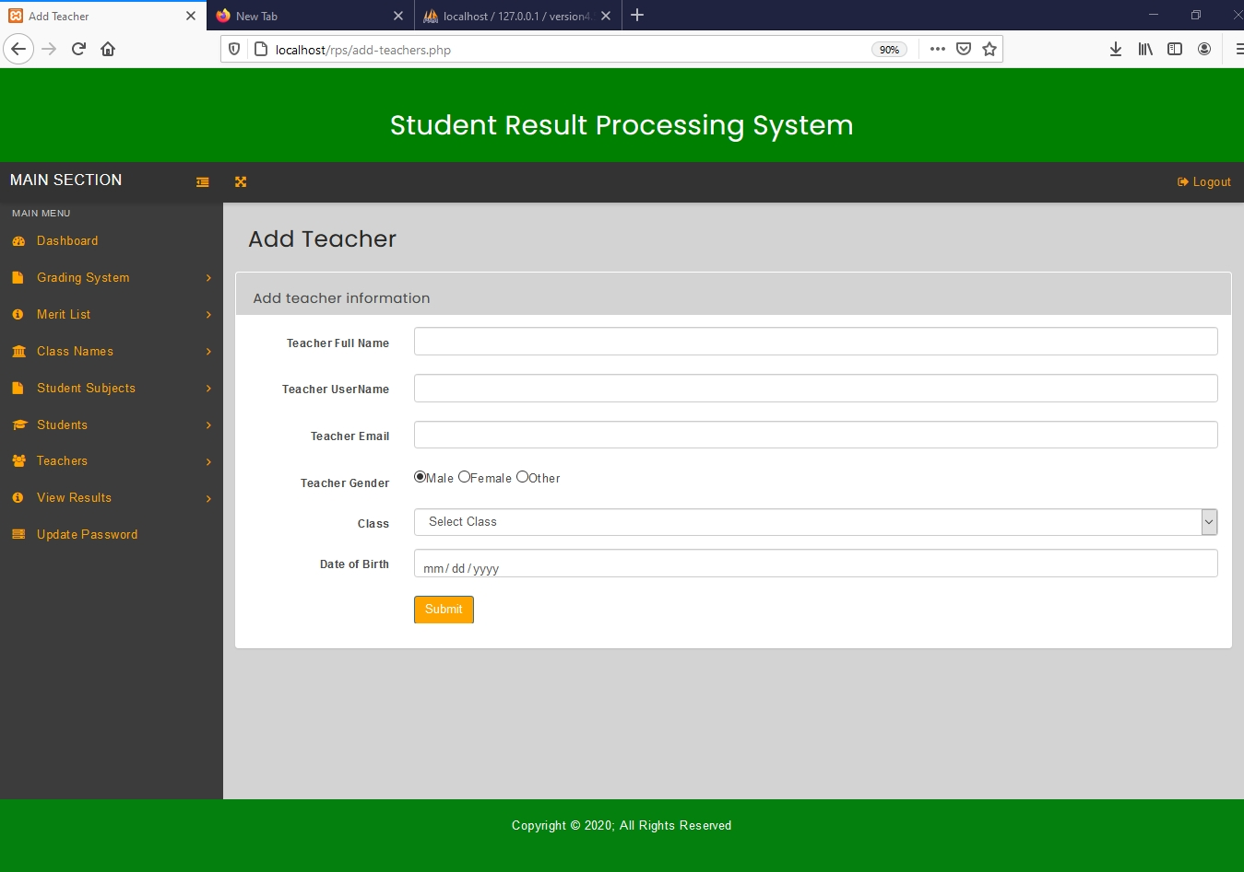

Figure 4.1.29, Add Teacher Page.

4.1.22 View Added Teachers

To view added teachers, click on the back link for the browser or click the ‘Teachers’ link under Teachers on the left navigation bar. This action will redirect to Add or Edit Teachers page which will display the added teachers in a table.

The table will have the Name of Teacher, User Name, Class, Reg Date, status, as well as an action column.

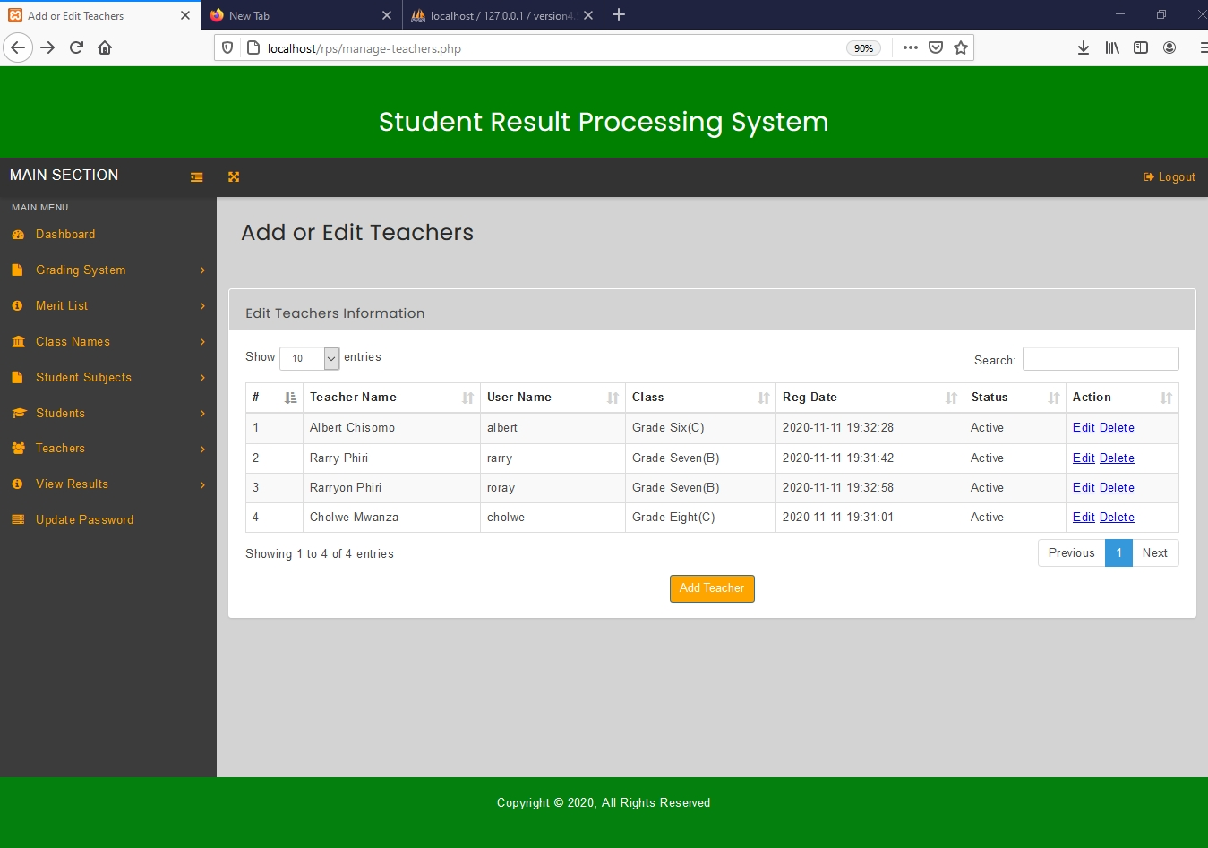

Figure 4.1.30, A filled Add or Edit Teachers page.

4.1.23 Edit Teachers

To edit added teachers, click the ‘Teachers’ link under Teachers in the left navigation bar. This action will redirect to Add or Edit Teachers page (Figure 4.1.30) which will display the teachers in a table.

Then click on ‘Edit’ link in Actions Column for the teacher you want to edit. This will lead to the edit teacher page.

The edit teacher page, will display input fields with values already filled in, which can be changed. All the fields can be edited and their values replaced except for the teacher`s class field. To save the changes made click the ‘update’ button. To go back click the ‘Back’ link.

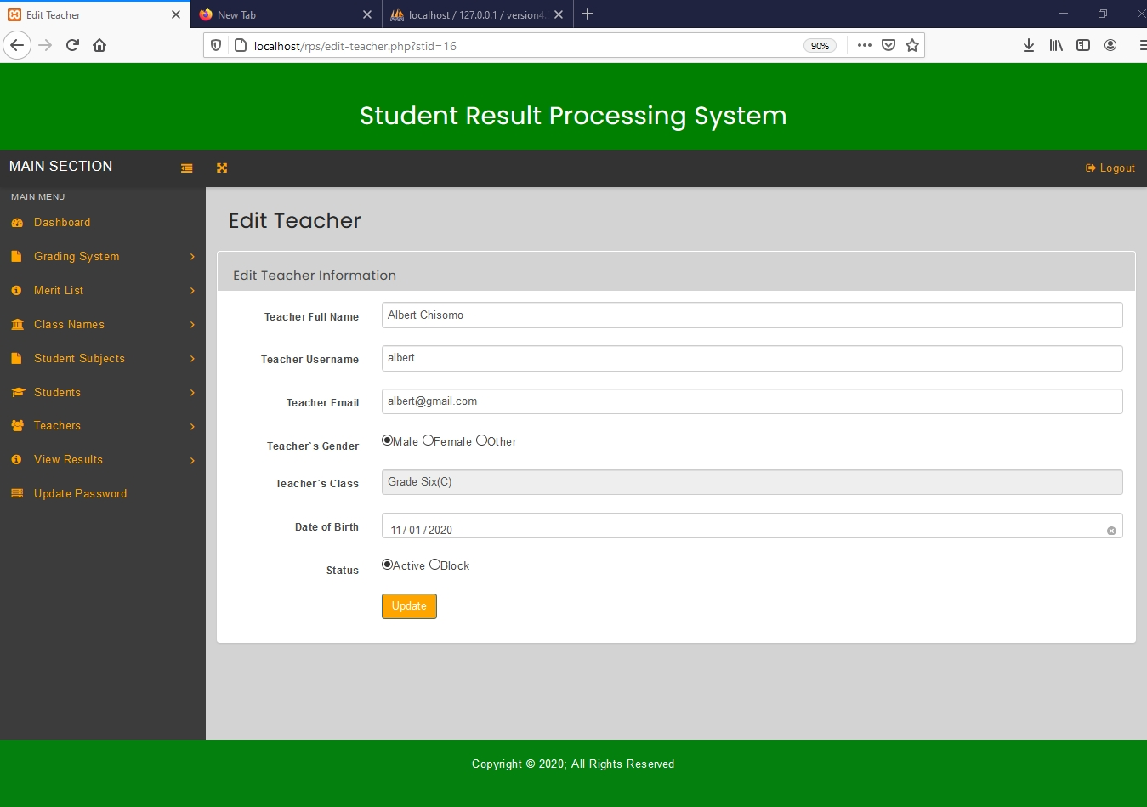

Figure 4.1.31, Edit Teacher page.

4.1.24 Delete Teacher

To delete a teacher, click the ‘Teachers’ link under Teachers on the left navigation bar. This action will redirect to Add or Edit Teachers page (Figure 4.1.30) which will display the teachers in a table.

Then click on ‘Delete’ link in Actions Column for the teacher you want to delete. Then the teacher will be deleted from the system.

4.1.25 View Results

After results have been added by the teacher, the head teacher can view results by performing the following actions.

To view results, click the “View Result” link under View Results on the left navigation bar. This action will redirect user to View Results page which will display the students information as well as a view link in the Action Column in a table.

To view results for each student simply click on view in the Action Column for the student you want to view the results. This action will redirect you to student results page which displays a report card for that particular student. Note that the teacher has to add End of Term Results for the report card to be generated.

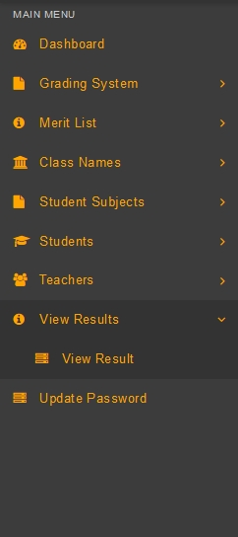

Figure 4.1.32, Left navigation bar with view results selected

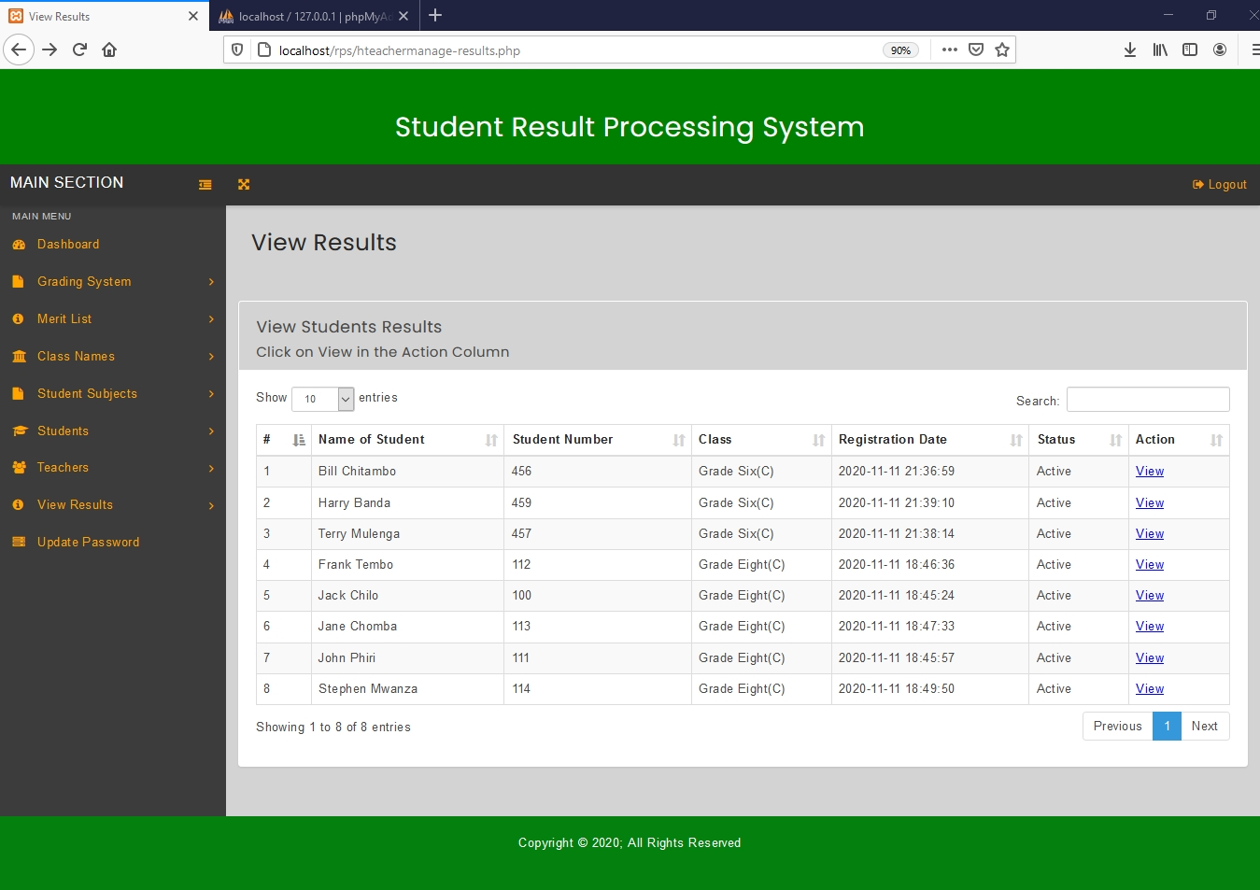

Figure 4.1.33, View Results page

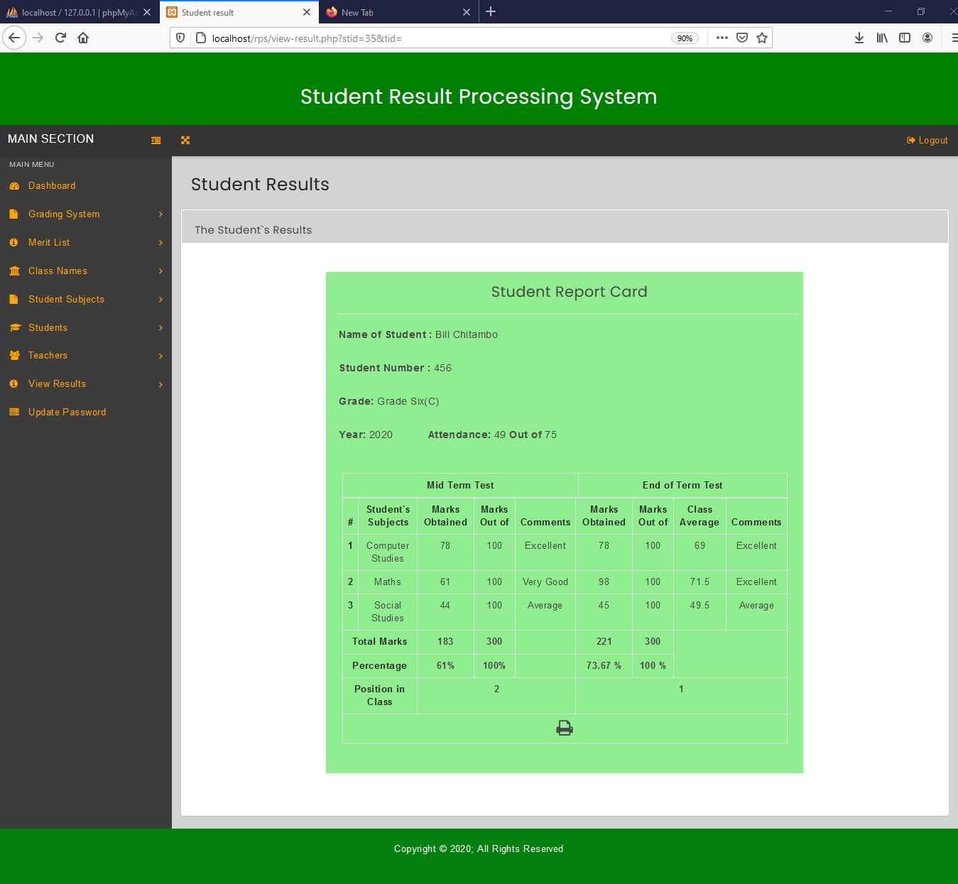

Figure 4.1.34, Student Results page

4.1.26 View Merit List For End of Term Results

To view a merit list for End of Term Results, click the “End of Term Merit List” link under Merit List on the left navigation bar. This action will redirect to Check End of Term Merit List page. On the Check End of Term Merit List page, you can select the class for which you want to view the merit list.

After the class has been selected, click the check button to view the merit list. This action will redirect user to the End of Term Merit List page which contains a table that has Name of Student, Student Number, Marks Obtained and Total Marks.

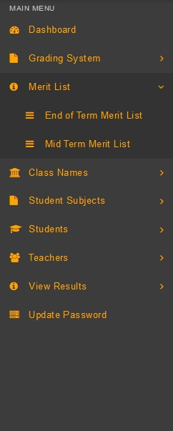

Figure 4.1.35, Left navigation bar with merit list section selected.

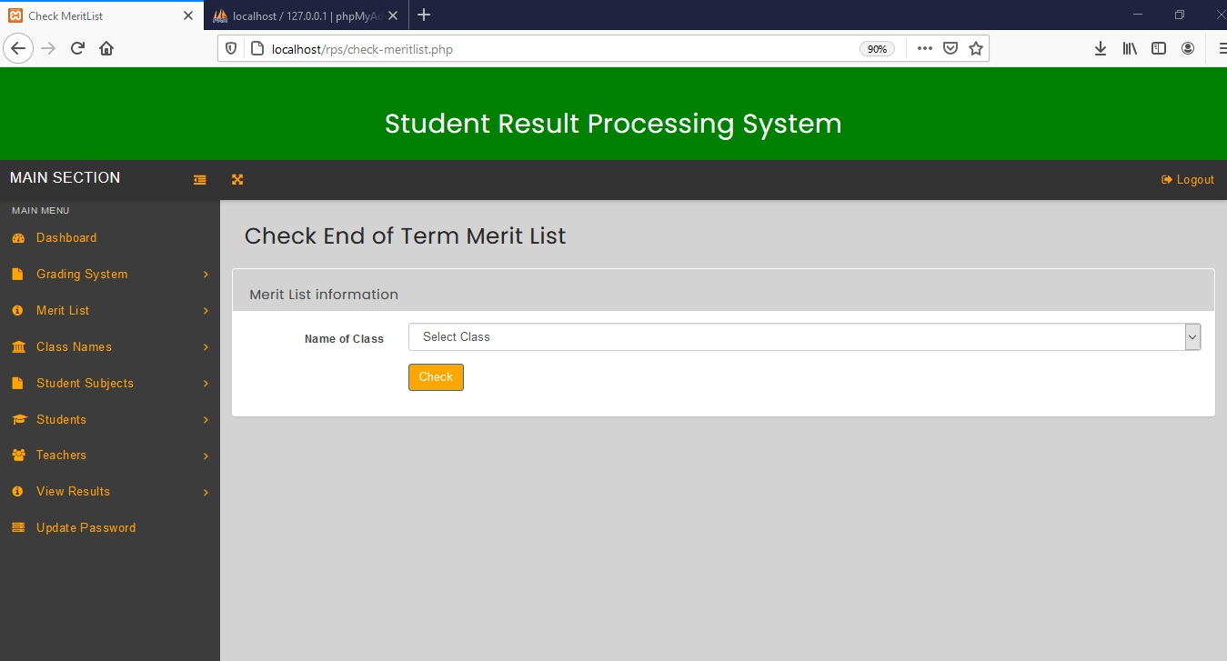

Figure 4.1.36, Check End of Term Merit List page

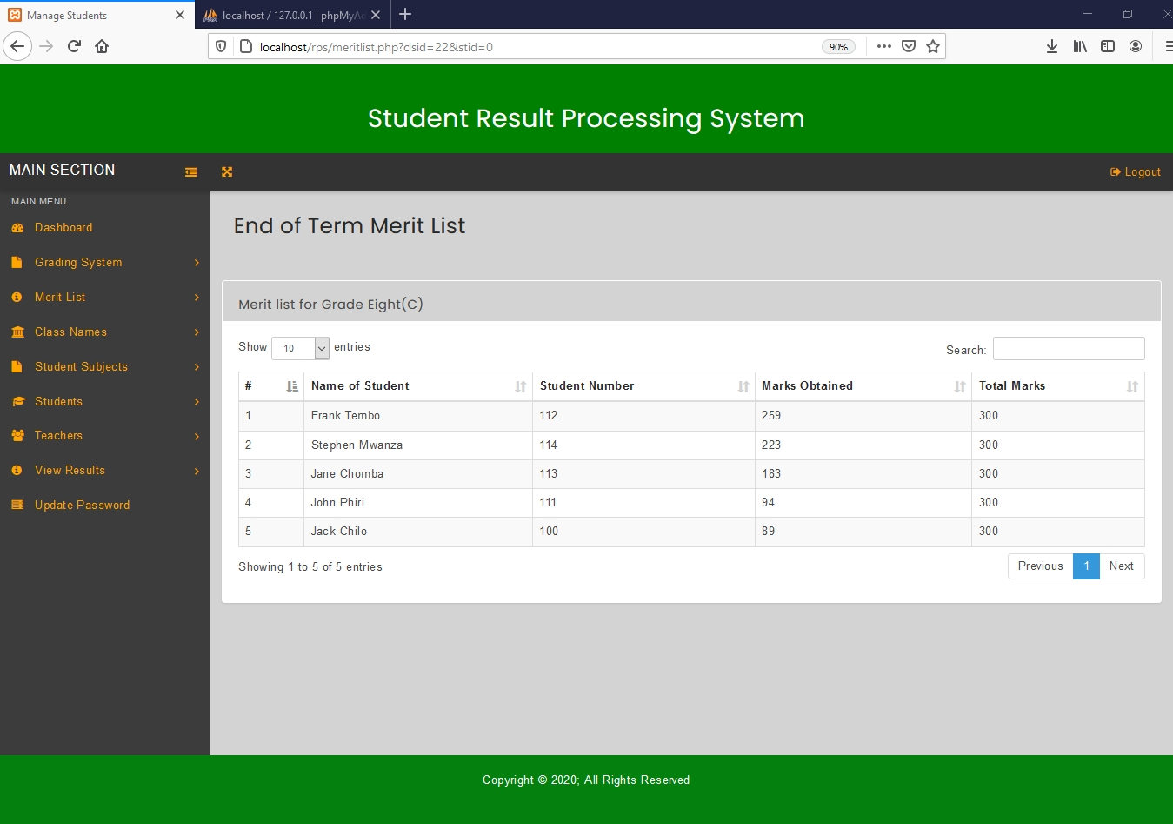

Figure 4.1.37, End of Term Merit List

4.1.27 View Merit List for Mid Term Results

To view a merit list for Mid Term Results, click the “Mid Term Merit List” link under Merit List on the left navigation bar. This action will redirect to Check Mid Term Merit List page. On the Check Mid Term Merit List page, you can select the class for which you want to view the merit list.

After the class has been selected, click the check button to view the merit list. This action will redirect user to the Mid Term Merit List page which contains a table that has Name of Student, Student Number, Marks Obtained and Total Marks.



Figure 4.1.38, Left navigation bar with merit list section selected

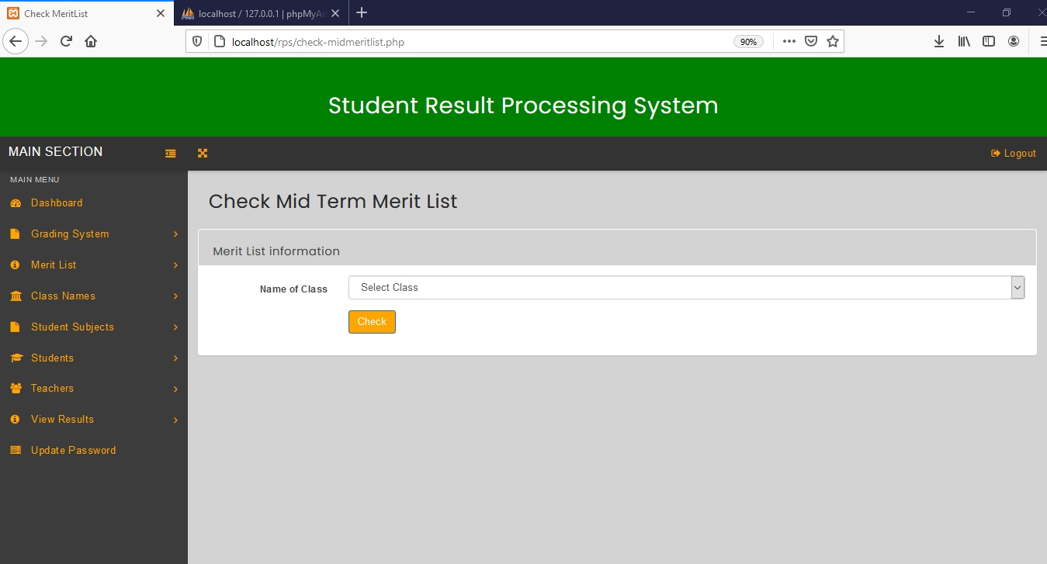

Figure 4.1.39, Check Mid Term Merit List page

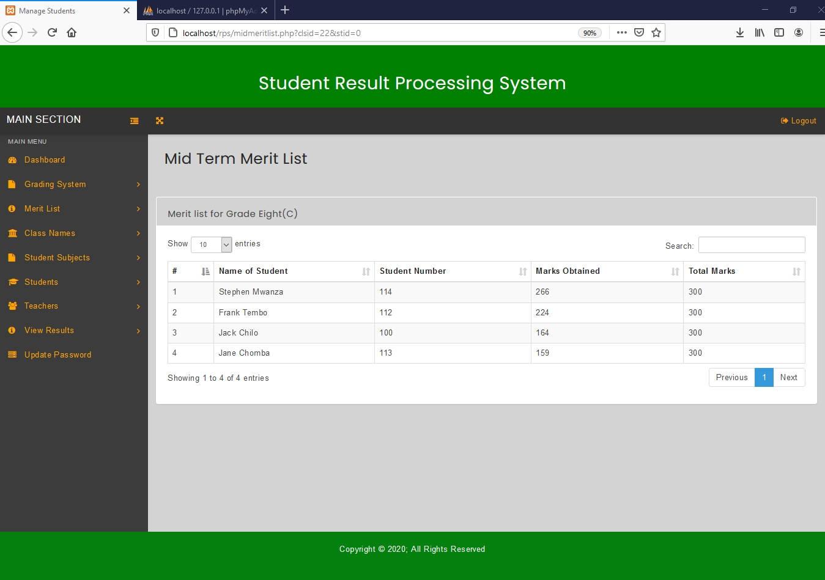

Figure 4.1.40, Mid Term Merit List.

**4.2 Teacher**

**4.2.1 Teacher Dashboard**

Once the user “teacher” has logged in successfully into the system, he/she should be about to see the dashboard as shown in figure 6.9 which has a left navigation bar, top bar, and dashboard stats. The dashboard stats display the total number of subjects the teacher`s class has, the number of classes the class teacher is responsible for, and also the total number of published mid-term results as well as the total number of published end of term results. On these dashboard stats the user “teacher” can click on view to see detailed information about the class subjects, teacher`s classes, midterm results and end of term results. Initially the dashboard stats for mid-term and end of term results will display zero because no results have been added to the system yet.

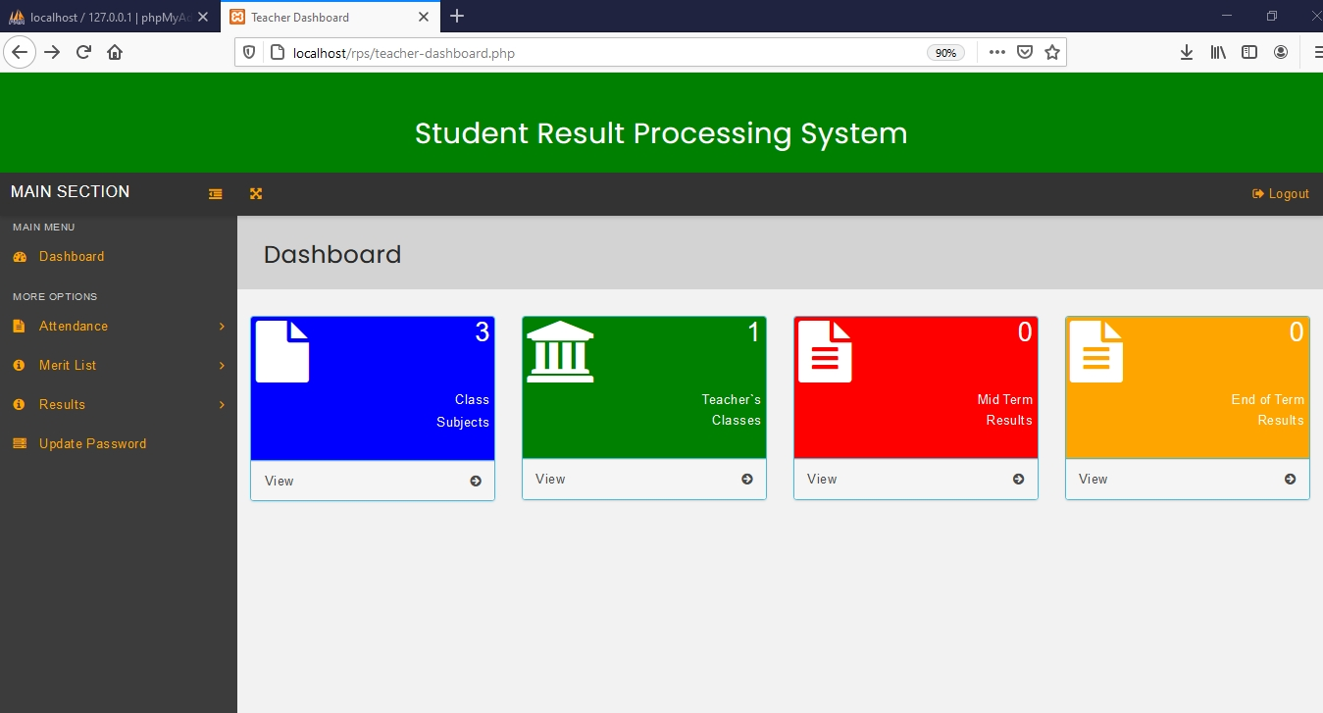

Figure 4.2.1, Teacher Dashboard

The teacher should be able to perform the following operations:

4.2.2 Add Attendance

To add attendance for a student, click the ‘Attendance’ link under Student Attendance on the left navigation bar. Then click the ‘Add’ button on the Add or Edit Attendance page which redirects to the add attendance page. On this page, select the student you want to add attendance information for and then click on ‘select’. After clicking on select you will be redirected to another add attendance page where you can fill in the attendance information.

On this page, fill in the input fields by providing the number of days attended, the total number of days the student is supposed to attend and the year of attendance. After filling in the information, click the ‘submit’ button to add attendance.

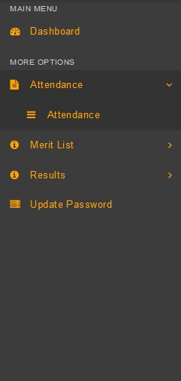

Figure 4.2.2, Teacher Left navigation bar with attendance selected

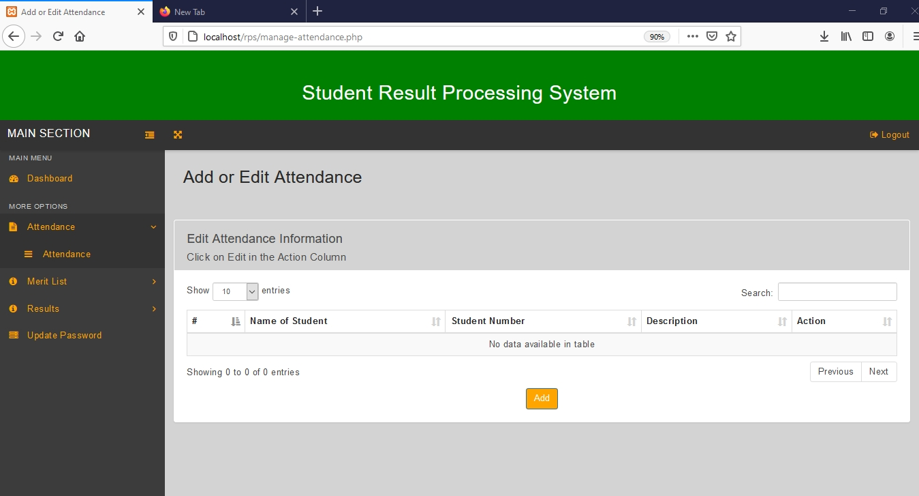

Figure 4.2.3, Add or Edit Attendance page.

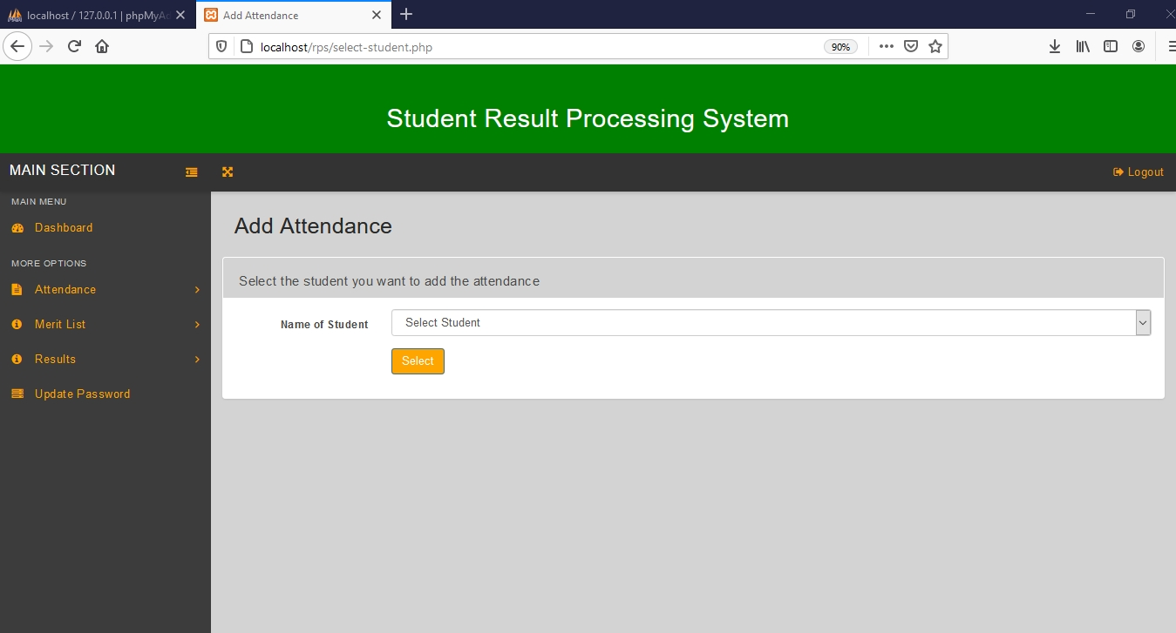

Figure 4.2.4, Add Attendance page for selecting student

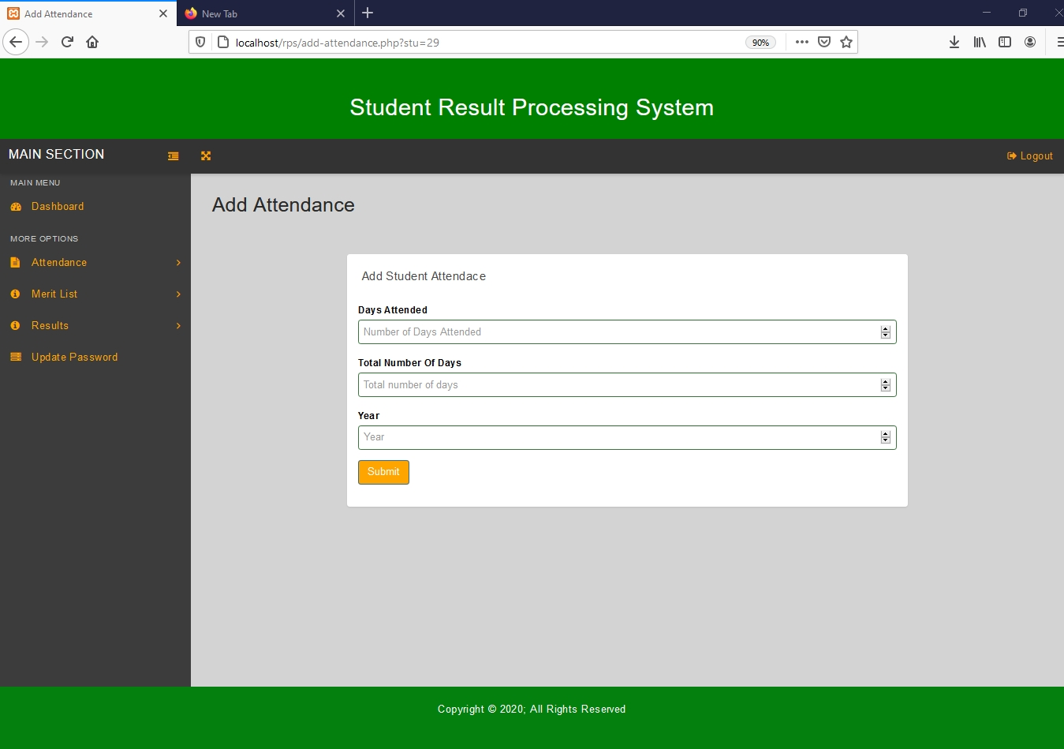

Figure 4.2.5, Add Attendance page for filling attendance information

4.2.3 View Attendance Information

To view added attendance information, click on the back link at the top of the browser or click the ‘Attendance’ link under Attendance in the left navigation bar. This action will redirect to Add or Edit Attendance page which will display the attendance for students in a table.

The table will have the name of student, student number, attendance description as well as an action column.

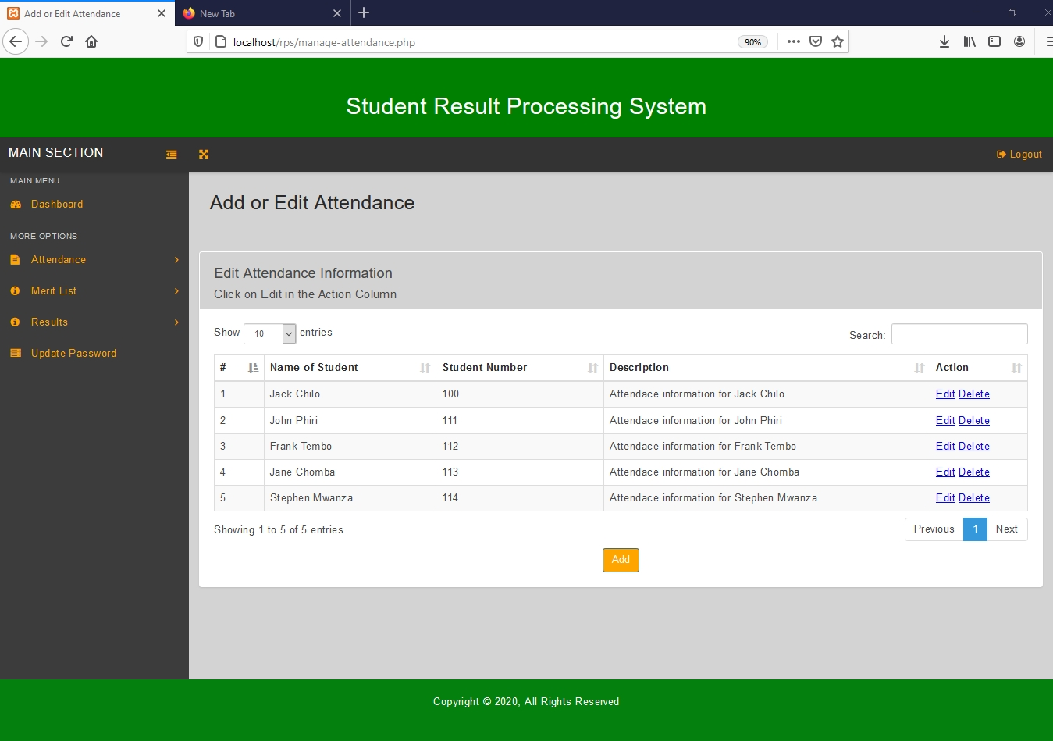

Figure 4.2.6, A filled Add or Edit Attendance page

4.2.4 Edit Attendance Information

To edit attendance information, click the ‘Attendance’ link under Attendance in the left navigation bar. This action will redirect to Add or Edit Attendance page (Figure 4.2.6) which will display the attendance information in a table.

Then click on ‘Edit’ link in Actions Column on the row containing the student you want to edit the attendance information. This will lead to the edit attendance page.

The edit attendance page, will display input fields with values already filled in, which can be changed. The days attended, total number of days and year can be edited or changed. To save the changes made click the ‘update’ button. To go back click the ‘Back’ link at the top of the browser.

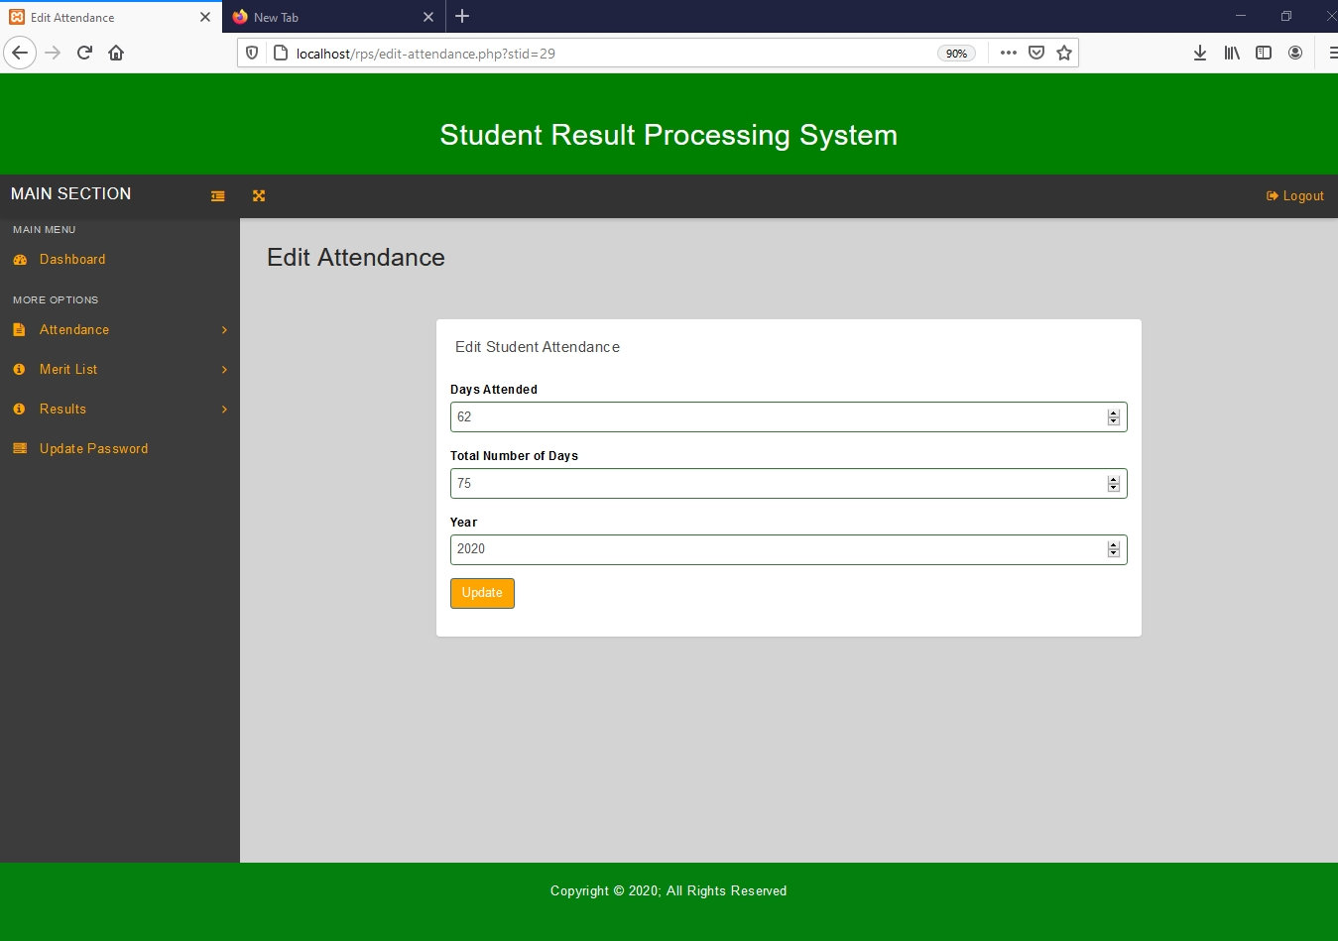

Figure 4.2.7, Edit Attendance page

4.2.5 Delete Attendance Information

To delete attendance information, click the ‘Attendance’ link under Attendance on the left navigation bar. This action will redirect to Add or Edit Attendance page (Figure 4.2.6) which will display student attendance information in a table.

Then click on ‘Delete’ link in Actions Column on the row containing the student you want to delete the attendance information. Then the attendance information for that particular student will be deleted from the system.

4.2.6 Add End of Term Results

To add End of Term Results, click the ‘End of Term Results’ link under Results on the left navigation bar. This leads to the End of Term Results page. On this page, click the ‘Publish Result’ button page which redirects to the Publish End of Term Results page.

On the Publish End of Term Results page, select the name of the class and student you want to publish the End of Term results, then input fields under subjects will be generated depending on the class name selected, fill in all the input fields by entering the marks for each subject. Then Click the ‘Publish Result’ button after you are done, to add the End of Term results.

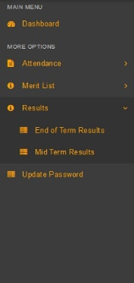

Figure 4.2.8, Left navigation bar with Results section selected

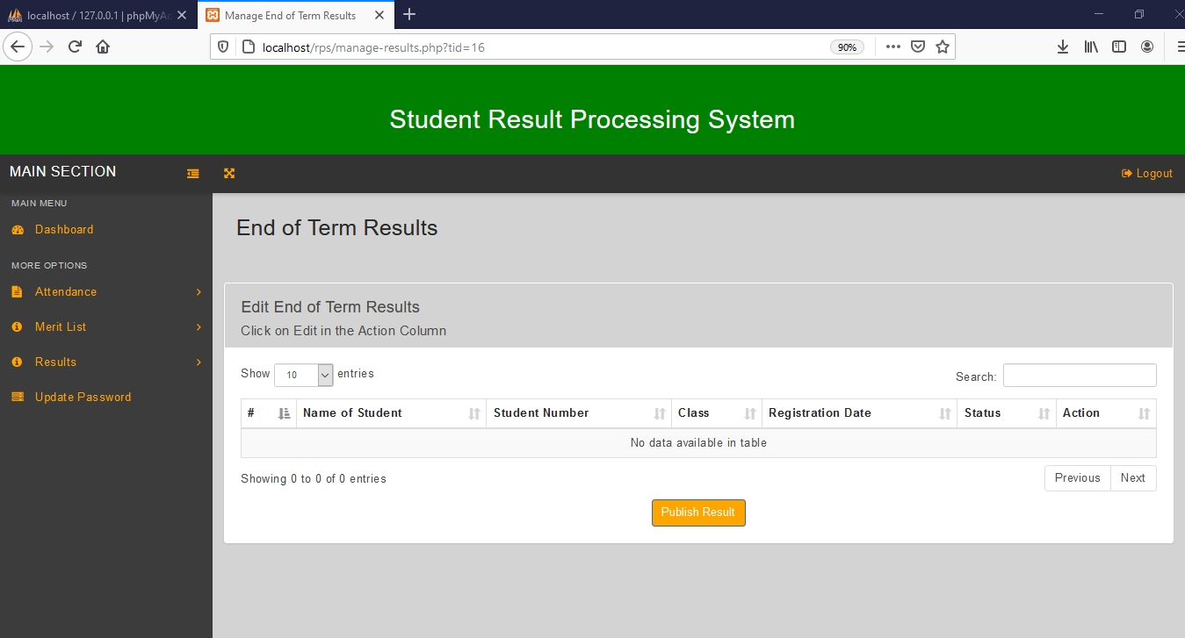

Figure 4.2.9, End of Term Results page.

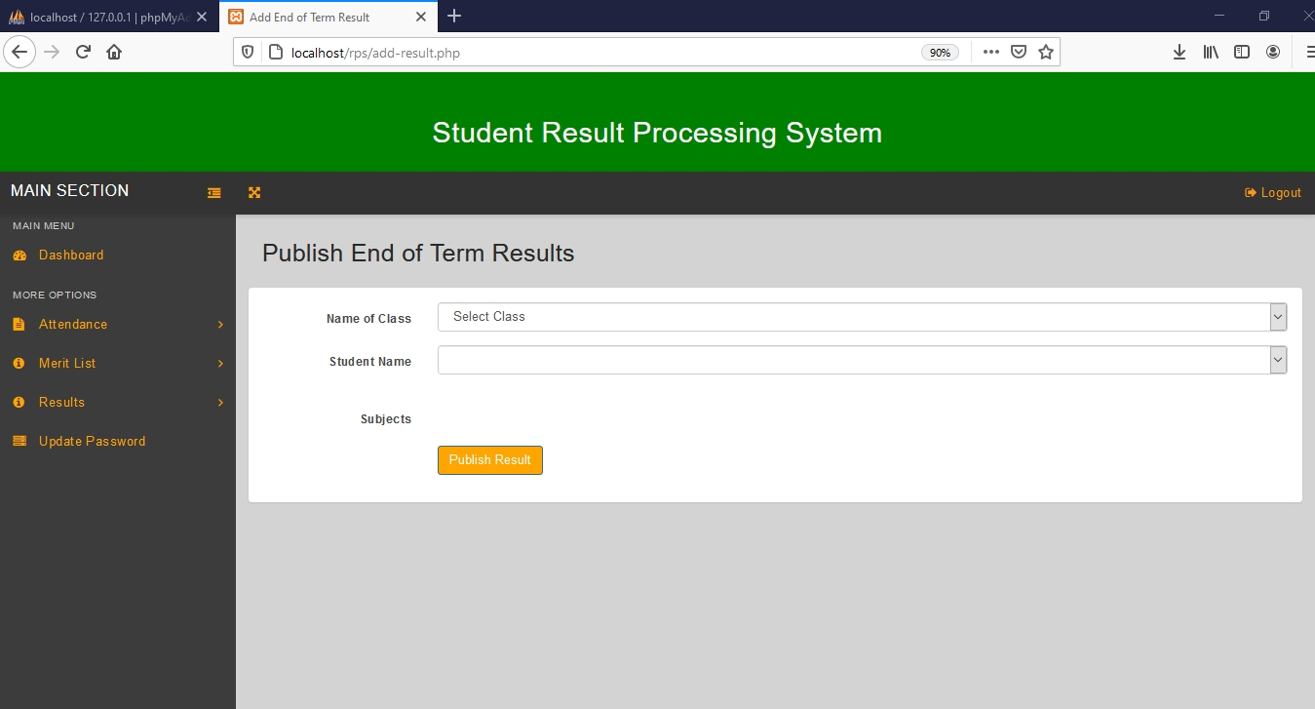

Figure 4.2.10, Publish End of Term Results page

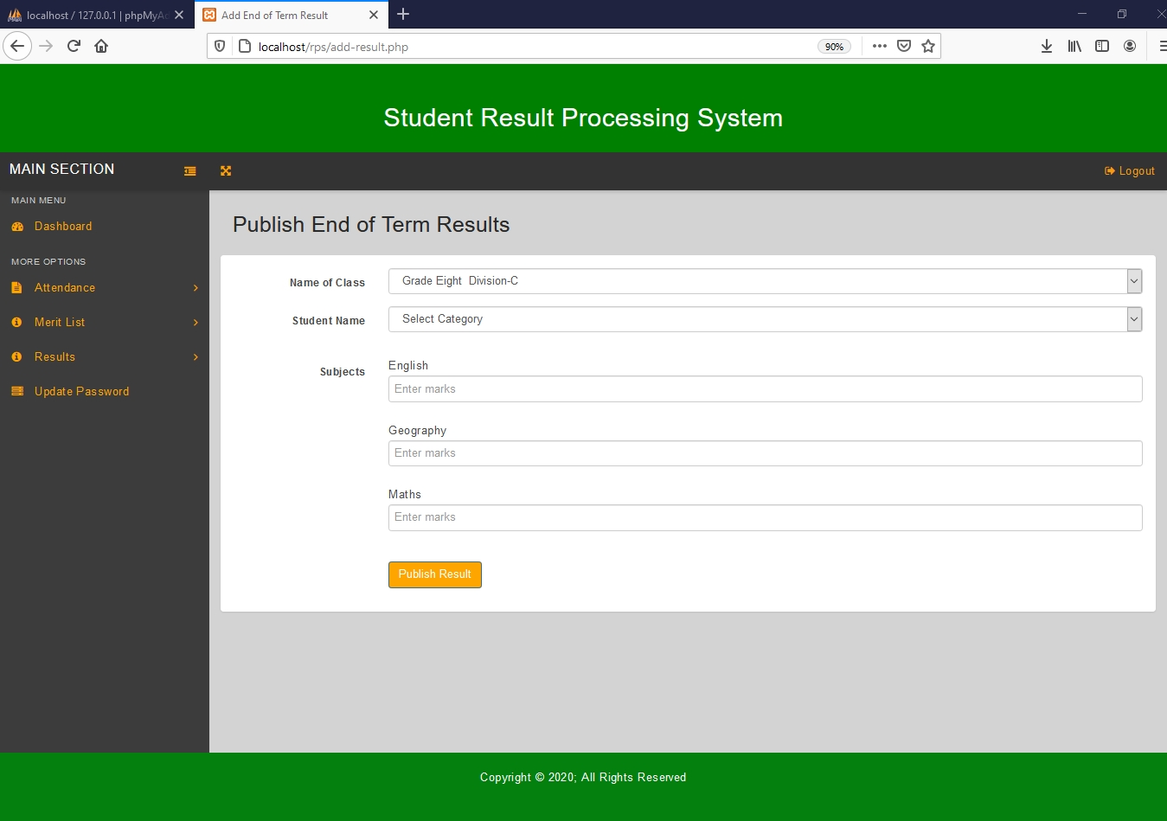

Figure 4.2.11, Publish End of Term Results page, with fields for entering marks.

4.2.7 View End of Term Results

To view end of term results, click on the back link for the browser or click the ‘End of Term Results’ link under Results on the left navigation bar. This action will redirect to End of Term Results page which will display the student’s information and available actions for their end of term results in a table.

End of Term results for students belonging to another class will only have the view as the available action because a teacher can`t edit end of term results for students who belong to another class.

The table will have the Name of Student, Student Number, Class, Registration Date, status, as well as an Action Column.

To view End of Term Result for each student simply click on view in the Action Column for the student you want to view the results.

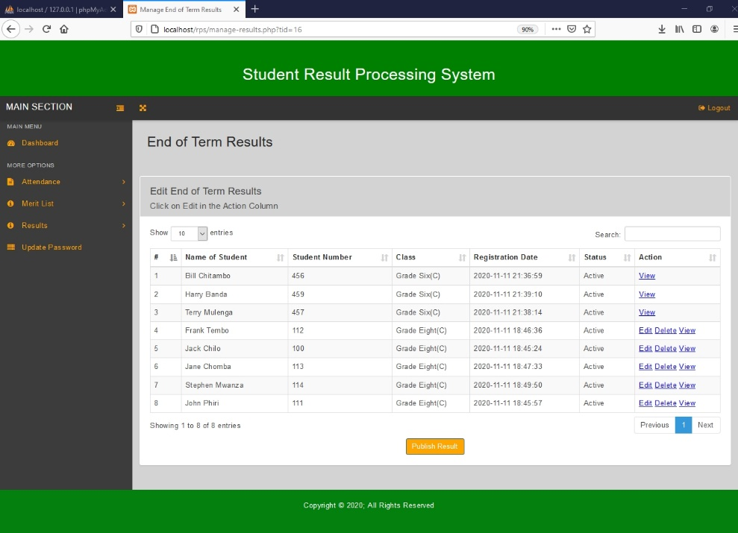

Figure 4.2.12, A filled End of Term Results page.

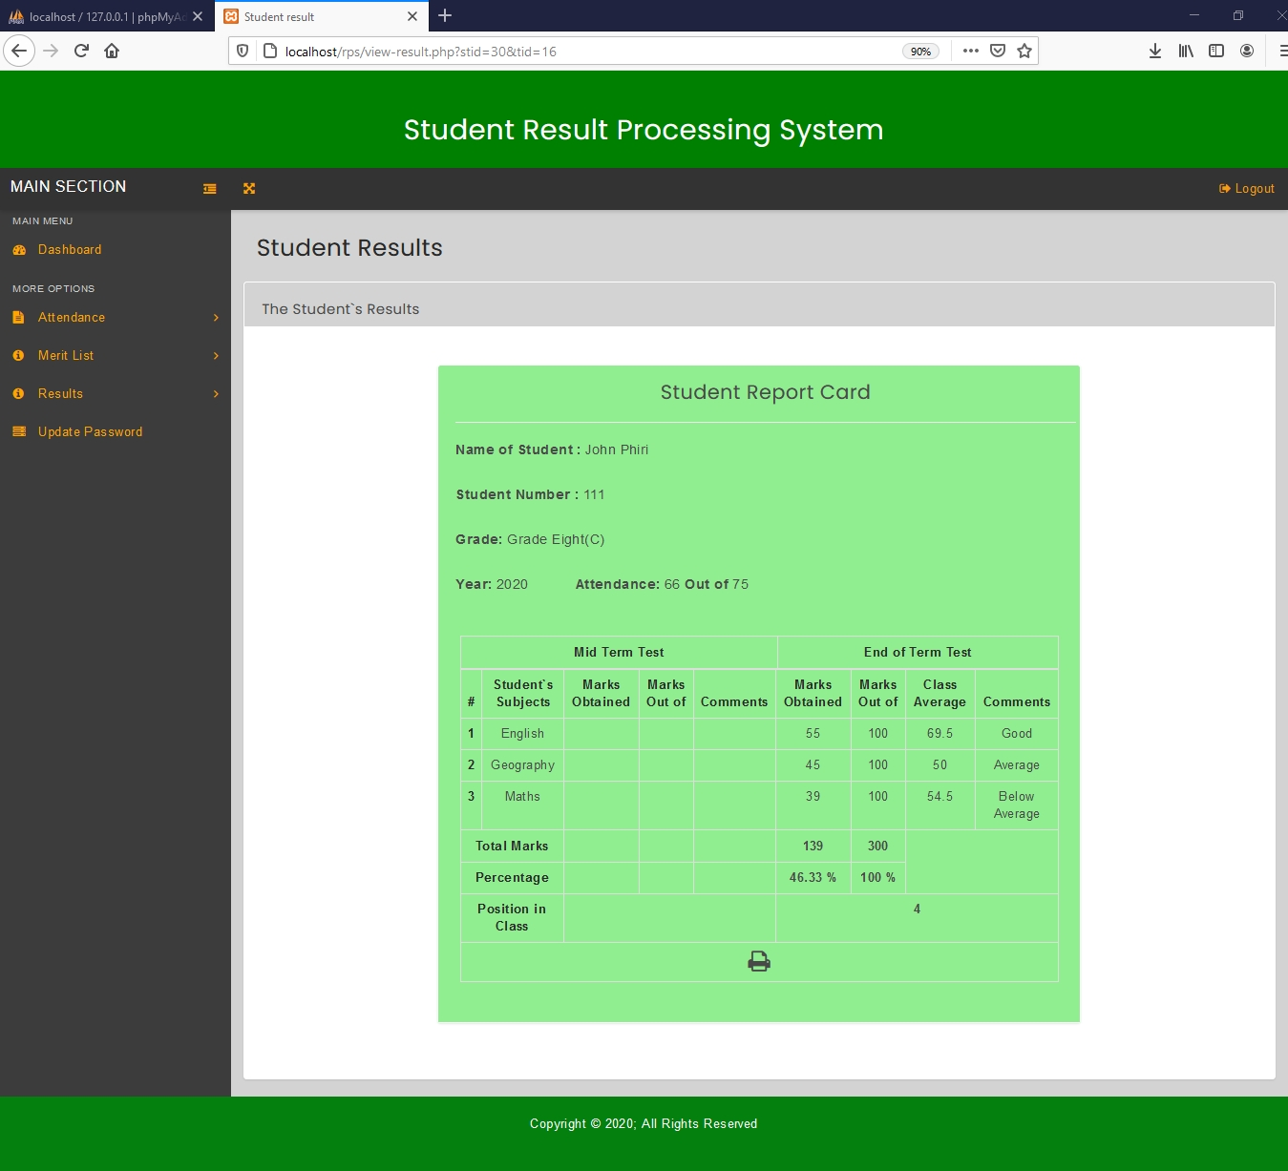

Figure 4.2.13, Student Report Card, showing only end of term results

4.2.8 Edit End of Term Results

To edit End of Term Results, click the ‘End of Term Results’ link under Results in the left navigation bar. This action will redirect to End of Term Results page (4.2.12) which will display the End of Term Results in a table.

The teacher can only edit End of Term Results if a student belongs to the his/her class.

If results are editable an edit link will appear in the action column, click on this link for the End of Term Results you want to edit. This will lead to the edit results page.

The edit results page, will display input fields with values already filled in, which can be changed. All the fields can be edited and their values replaced. To save the changes made click the ‘update’ button. To go back click the ‘Back’ link at the top of the browser.

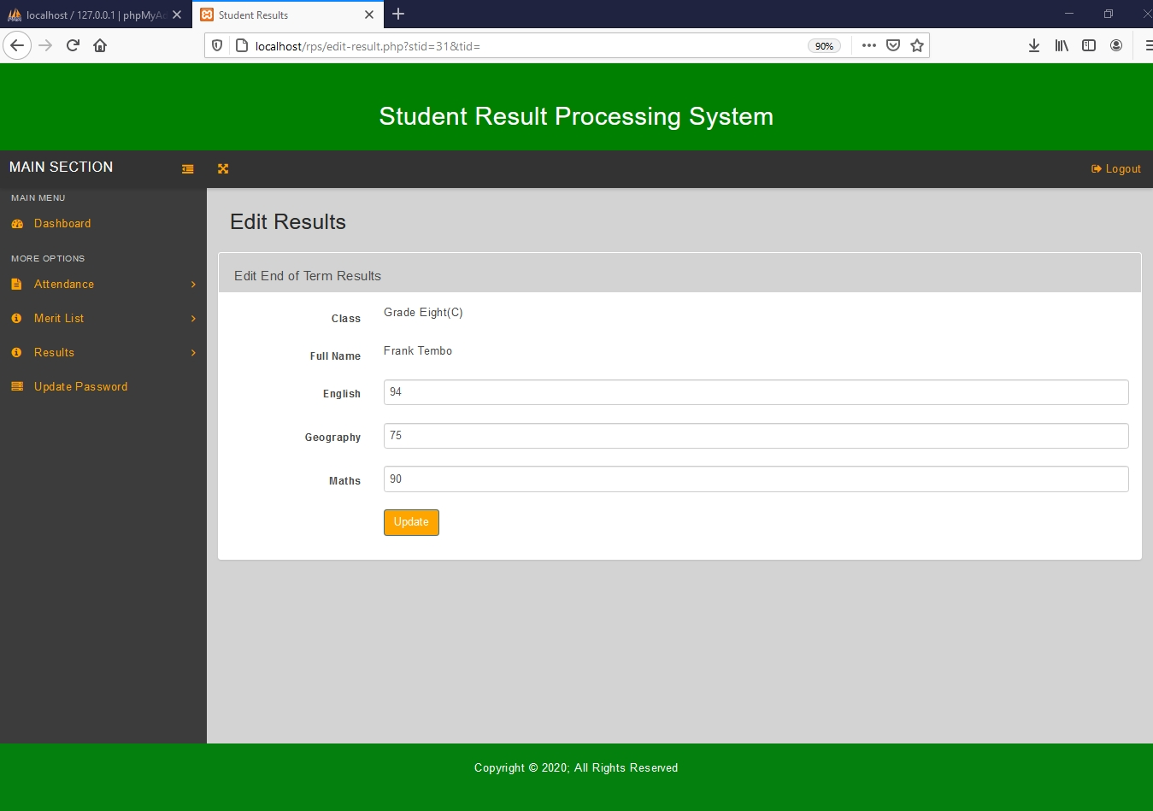

Figure 4.2.14, Edit Results page for end of term results

4.2.9 Delete End of Term Results

To delete End of Term Results, click the ‘End of Term Results’ link under Results on the left navigation bar. This action will redirect to End of Term Results page (4.2.12) which will display the student information and their results in a table.

The teacher can only delete End of Term Results if a student belongs to the his/her class.

If results are editable a delete link will be available in the action column. Then click on ‘Delete’ link in Actions Column for the End of Term Results you want to delete. Then the results will be deleted from the system.

4.2.10 Add Mid Term Results

To add Mid Term Results, click the ‘Mid Term Results’ link under Results on the left navigation bar. This leads to the Mid Term Results page. On this page, click the ‘Publish Result’ button page which redirects to the Publish Mid Term Results page.

On the Publish Mid Term Results page, select the name of the class and student you want to publish the Mid Term results, then input fields under subjects will be generated depending on the class name selected, fill in all the input fields by entering the marks for each subject. Then Click the ‘Publish Result’ button after you are done, to add the results.



Figure 4.2.15, Left navigation bar with Results section selected

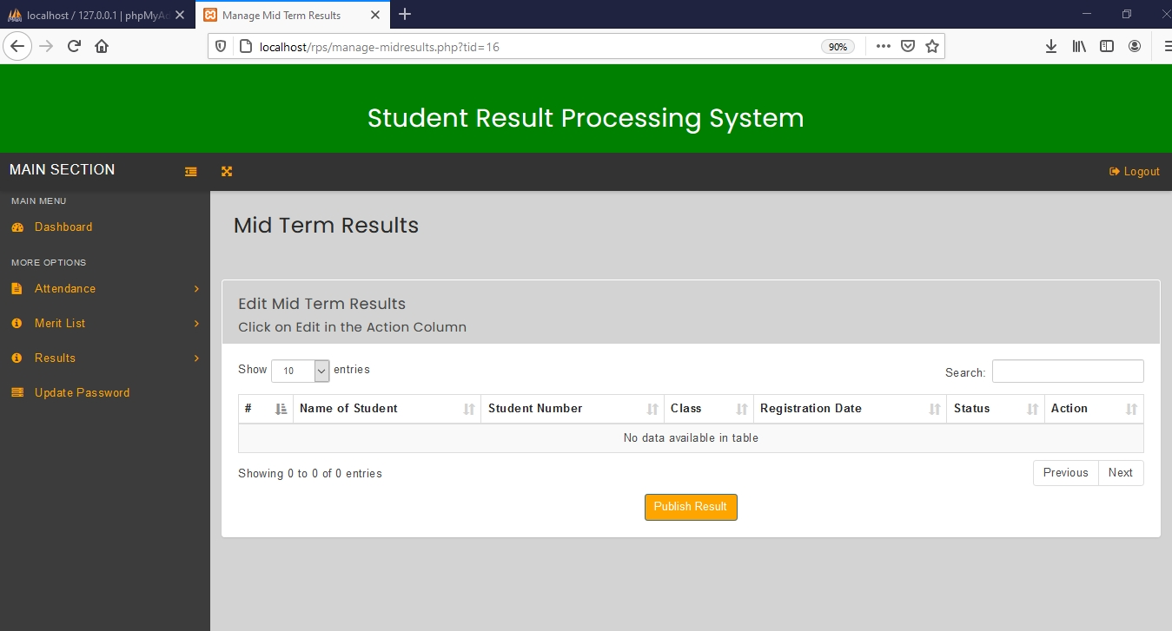

Figure 4.2.16, Mid Term Results page.

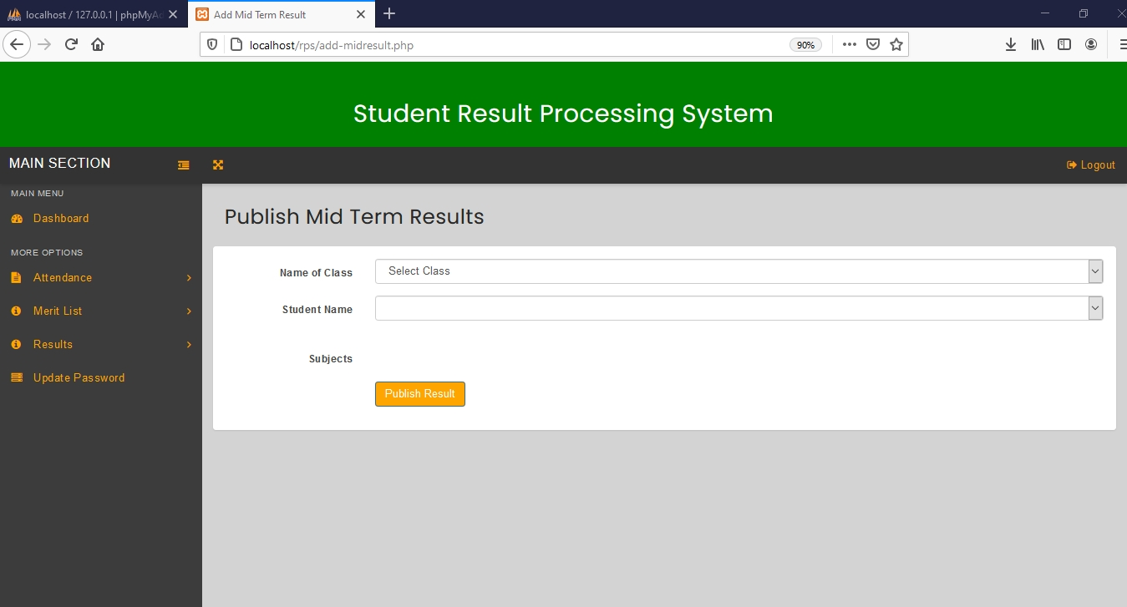

Figure 4.2.17, Publish Mid Term Results page

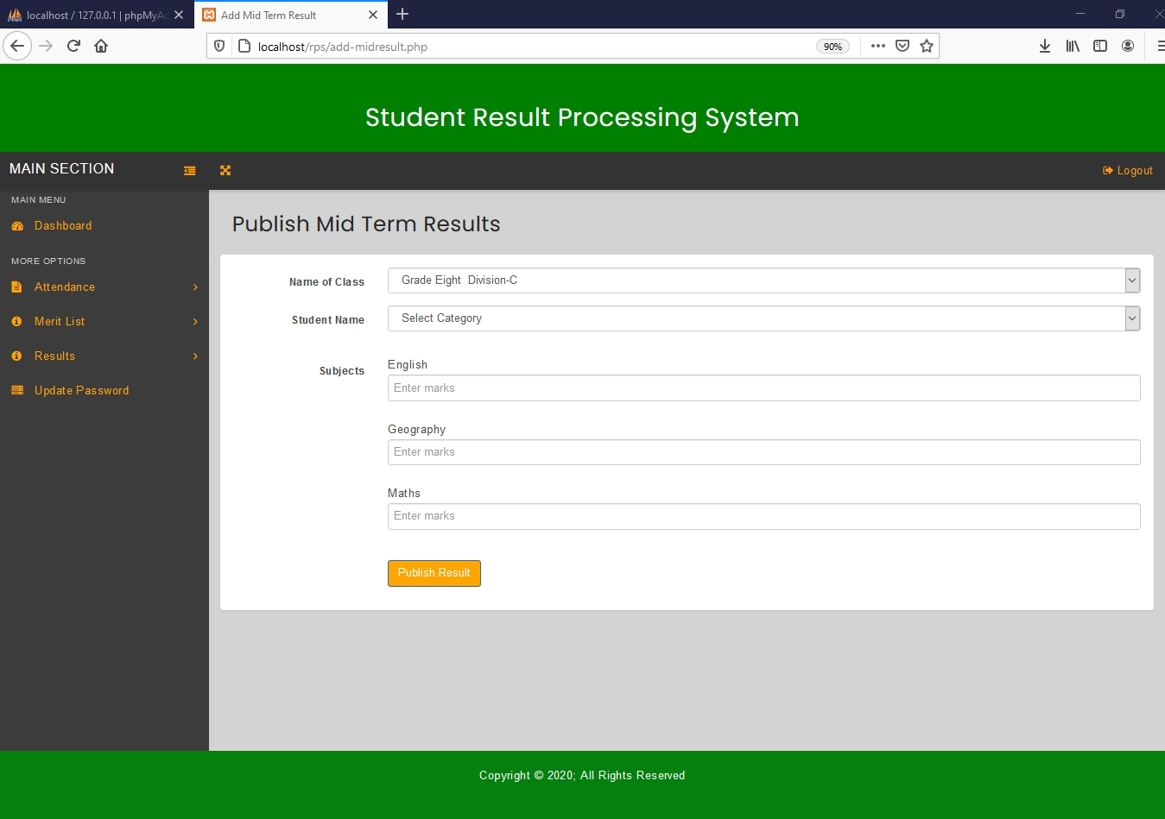

Figure 4.2.18, Publish Mid Term Results Page with input fields for entering marks.

4.2.11 View Mid Term Results

To view Mid Term results, click on the back link at the top of the browser or click the ‘Mid Term Results’ link under Results on the left navigation bar. This action will redirect to Mid Term Results page which will display the student’s information and available actions for their Mid Term results in a table.

Mid Term results for students belonging to another class will only have the view as the available action because a teacher can`t edit mid-term results for students who belong to another class.

The table will have the Name of Student, Student Number, Class, Registration Date, status, as well as an Action Column.

To view Mid Term Result for each student simply click on view in the Action Column for the student you want to view the results. Note that End of Term Results are required in order to generate report card.

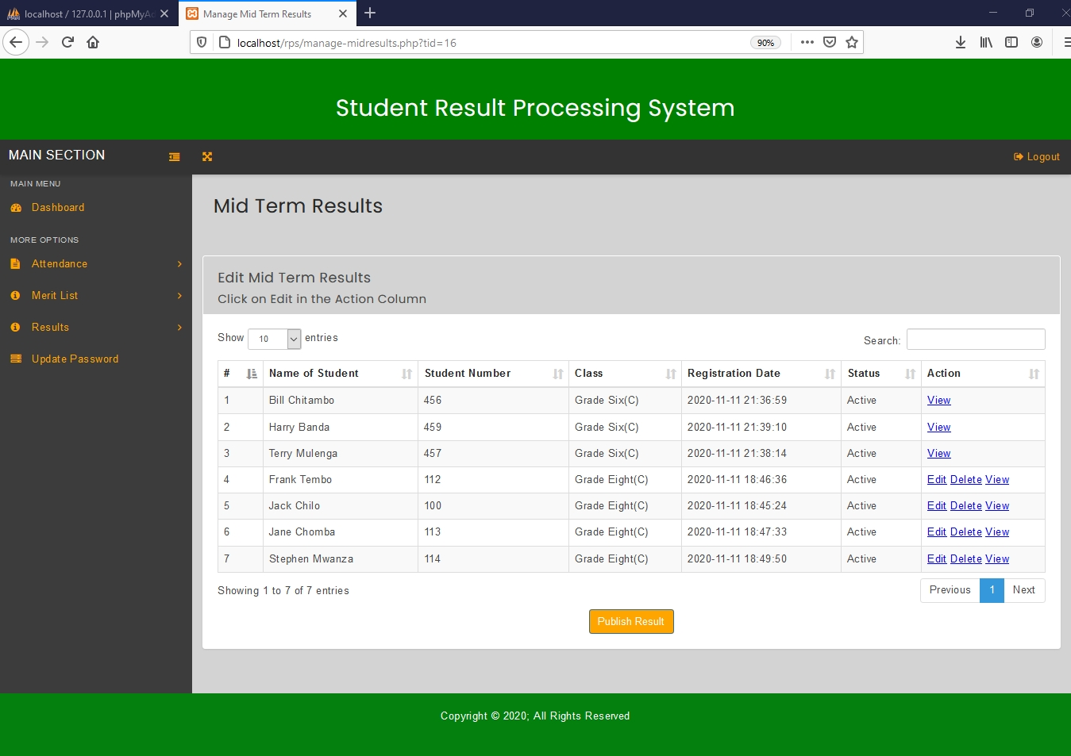

Figure 4.2.19, Mid Term Results page showing results for two different classes

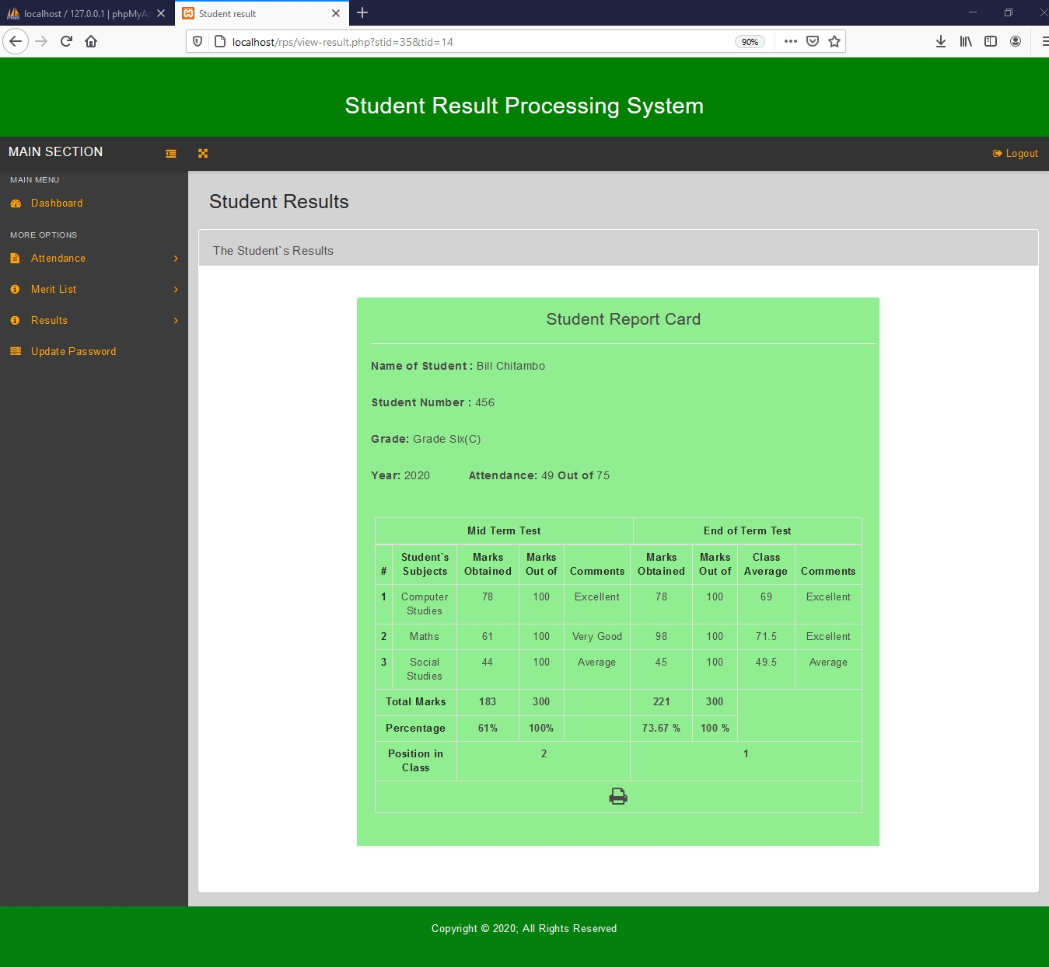

Figure 4.2.20, Student Report Card showing both end of term and mid-term results.

4.2.12 Edit Mid Term Results

To edit Mid Term Results, click the ‘Mid Term Results’ link under Results in the left navigation bar. This action will redirect to Mid Term Results page (Figure 4.2.19) which will display the Mid Term Results in a table.

The teacher can only edit Mid Term Results if a student belongs to the his/her class.

If results are editable an edit link will available in the action column, click on this link for the Mid Term Results you want to edit. This will lead to the edit Mid Term Results page.

The Edit Mid Term Results page, will display input fields with values already filled in, which can be changed. All the input fields can be edited and their values replaced. To save the changes made click the ‘update’ button. To go back click the ‘Back’ link for the browser.

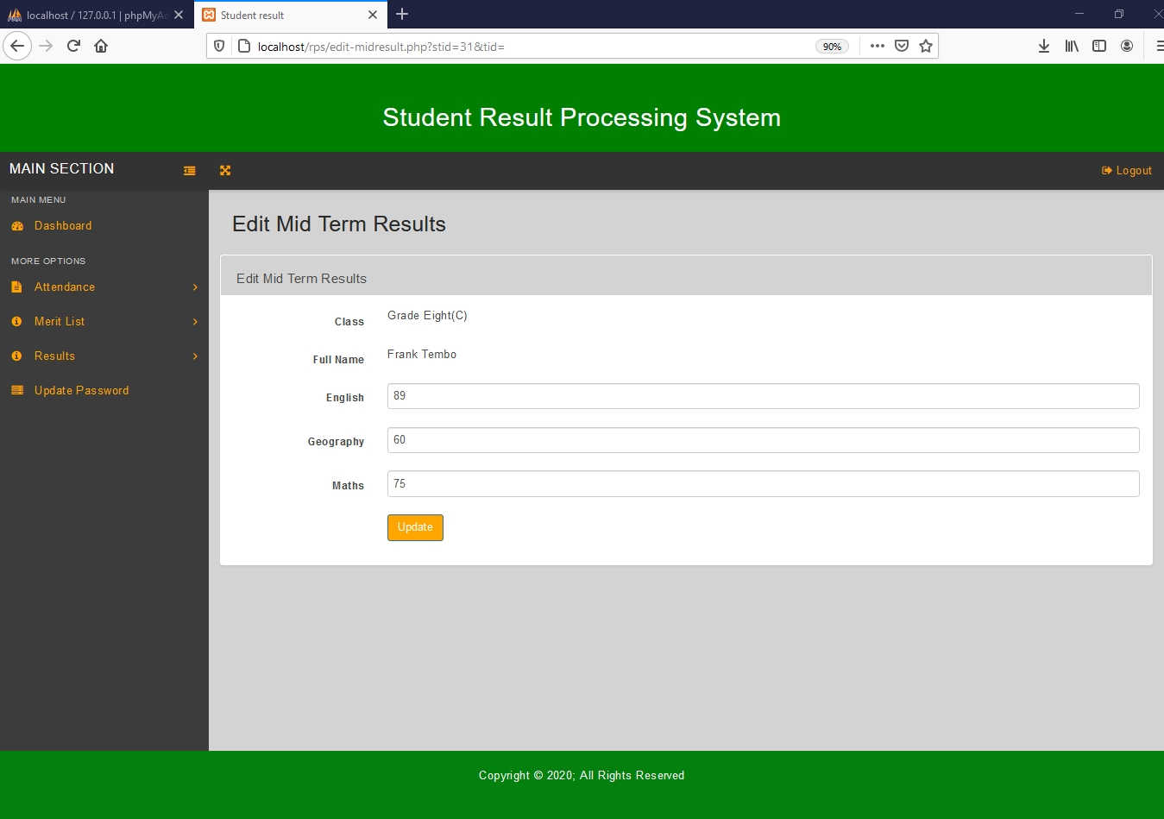

Figure 4.2.21, Edit Mid Term Results page.

4.2.13 Delete Mid Term Results

To delete Mid Term Results, click the ‘Mid Term Results’ link under Results on the left navigation bar. This action will redirect to Mid Term Results page (Figure 4.2.19) which will display the student information and their results in a table.

The teacher can only delete Mid Term Results if a student belongs to his/her class.

If results are editable a delete link will available in the action column. Then click on ‘Delete’ link in Actions Column for the Mid Term Results you want to delete. Then the mid-term results will be deleted from the system.

4.2.14 View Merit List for End of Term Results

To view a merit list for End of Term Results, click the “End of Term Merit List” link under Merit List on the left navigation bar. This action will redirect to Check End of Term Merit List page. On the Check End of Term Merit List page, you can select the class for which you want to view the merit list.

After the class has been selected, click the check button to view the merit list. This action will redirect user to the End of Term Merit List page which contains a table that has Name of Student, Student Number, Marks Obtained and Total Marks.

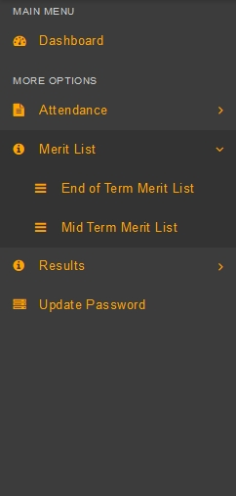

Figure 4.2.22, Teacher Left navigation bar with merit list section selected

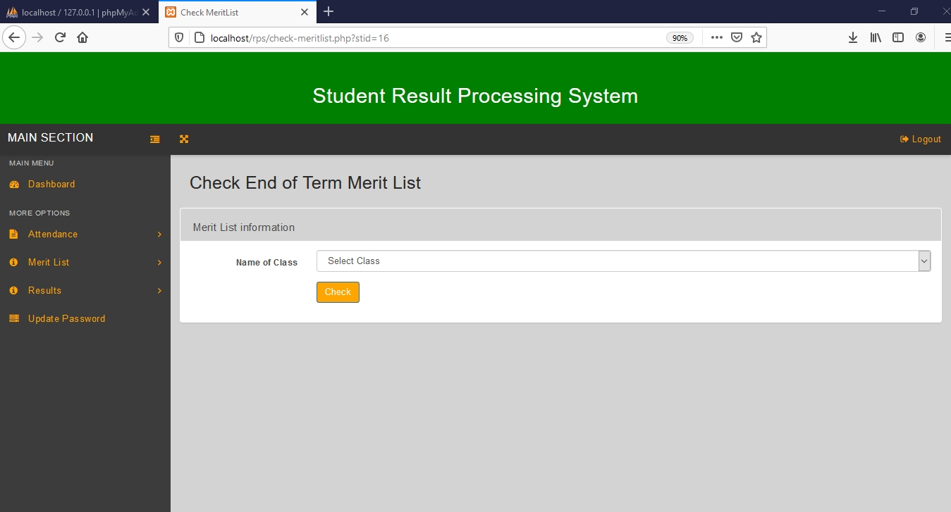

Figure 4.2.23, Check End of Term Merit List page

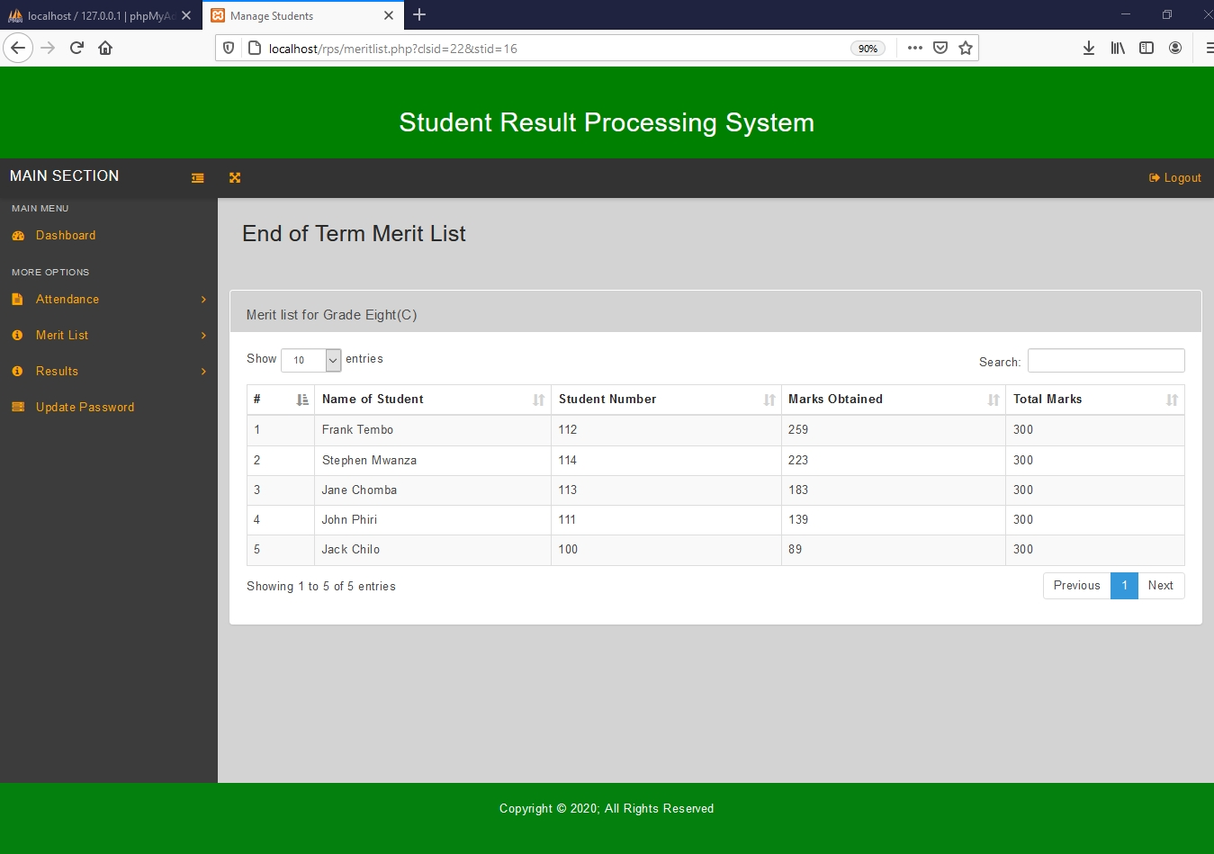

Figure 4.2.24, End of Term Merit List.

4.2.14 View Merit List for Mid Term Results

To view a merit list for Mid Term Results, click the “Mid Term Merit List” link under Merit List on the left navigation bar. This action will redirect to Check Mid Term Merit List page. On the Check Mid Term Merit List page, you can select the class for which you want to view the merit list.

After the class has been selected, click the check button to view the merit list. This action will redirect user to the Mid Term Merit List page which contains a table that has Name of Student, Student Number, Marks Obtained and Total Marks.



Figure 4.2.25, Teacher Left navigation bar with merit list section selected

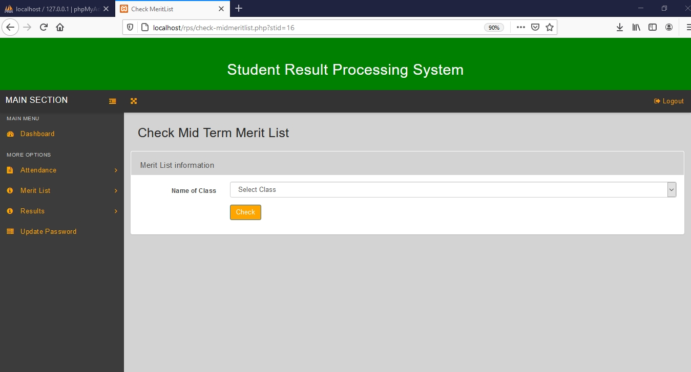

Figure 4.2.26, Check Mid Term Merit List page.

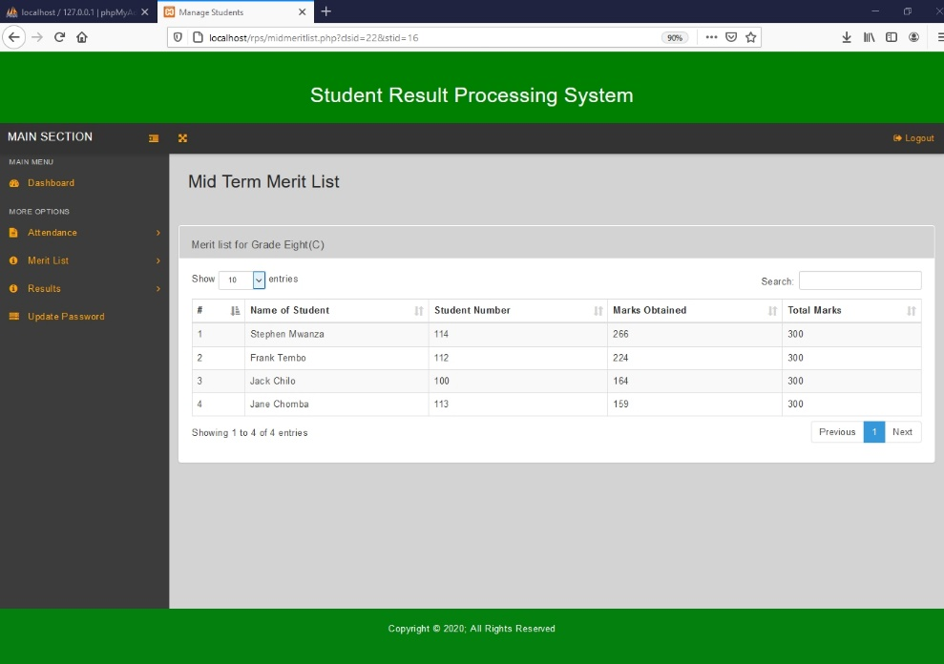

Figure 4.2.27, Mid Term Merit List.

**4.3 Student**

4.3.1 View Report Card

A logged in student can view his/her report card, which is automatically generated by the system. Figure 8.6 shows the report card for the student that is automatically generated by the system in the student portal. In addition to viewing report card, the student can perform general operations like printing the report card, updating the password, and logging out of the system ‘see page 3 General Operations’.

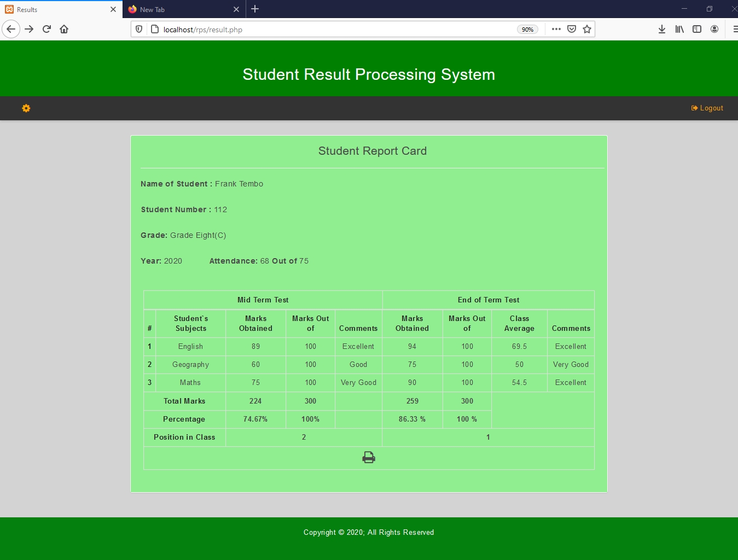

Figure 4.2.28, Report card with both mid-term and end of term results published.

**5 Appendix**

Below is a table of the available accounts that can be used to navigate through the system.

|  |  |  |
| --- | --- | --- |
| **TYPE OF USER** | **USERNAME** | **PASSWORD** |
| Head Teacher | headteacher | pass |
| Teacher | cholwe | pass |
| Teacher | albert | pass |
| Student | 112 | pass |
| Student | 100 | pass |
| Student | 113 | pass |
| Student | 114 | pass |
| Student | 111 | pass |
| Student | 456 | pass |
| Student | 459 | pass |
| Student | 457 | pass |